**Networking**

Contents

Task 1: Install ESXi on a VM 1

Task 2: Configure an ESXi Hosts 16

Task 3: Examine the ESXi Host Hardware Configuration 20

Task 4: Configure the Management Network: DNS and Routing information for an ESXi Host 42

Task 5: Deploy and Configure a Virtual Machine 59

Task 6: Install and Deploy vCenter Server Appliance 86

Task 7: Add Your ESXi Hosts to the vCenter Server Inventory 111

Task 8: Ensure High Availability 116

Task 9: Plan and Design Backup Strategy 117

Task 10: Reference 118

# Task 1: Install ESXi on a VM

The ESXi is installed on the virtual machine. First, open the virtual machine and create a new virtual machine. Then, click on the next button. These steps are represented in the below figures ("VMware vSphere 5.1", 2019).

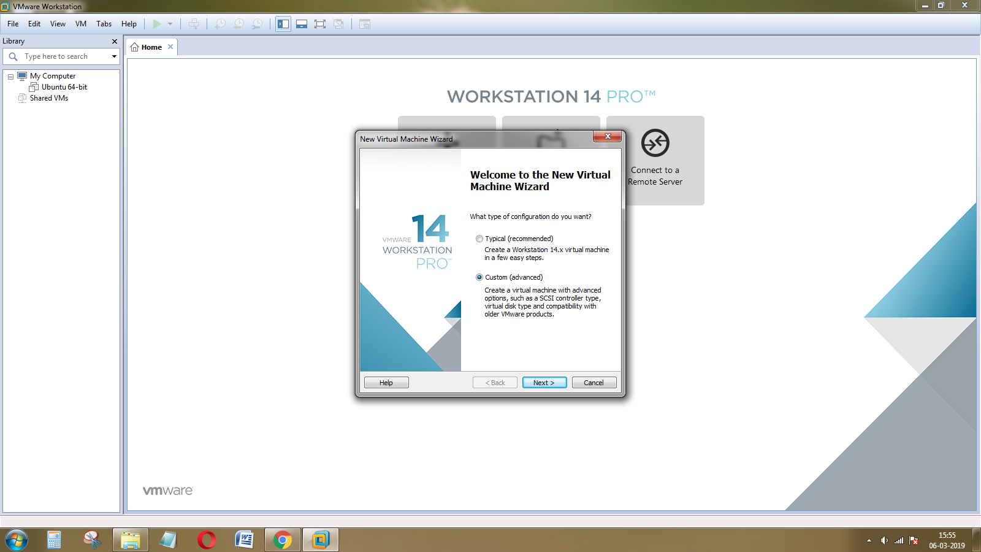

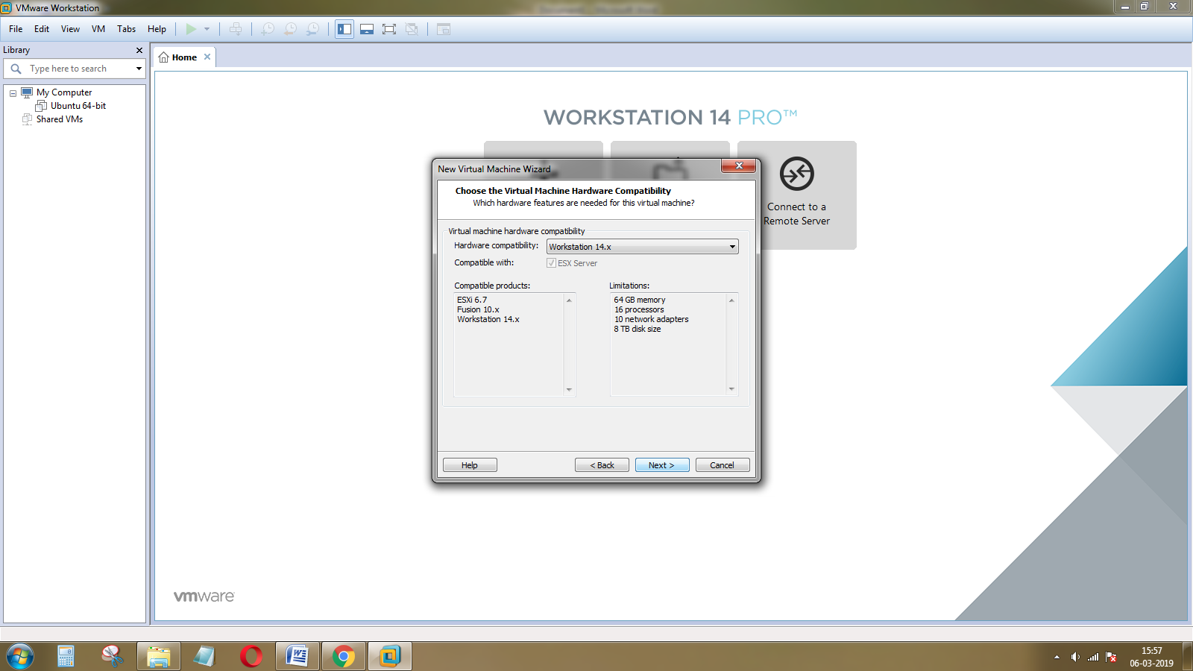

Select the hardware compatibility and click on the Next button.

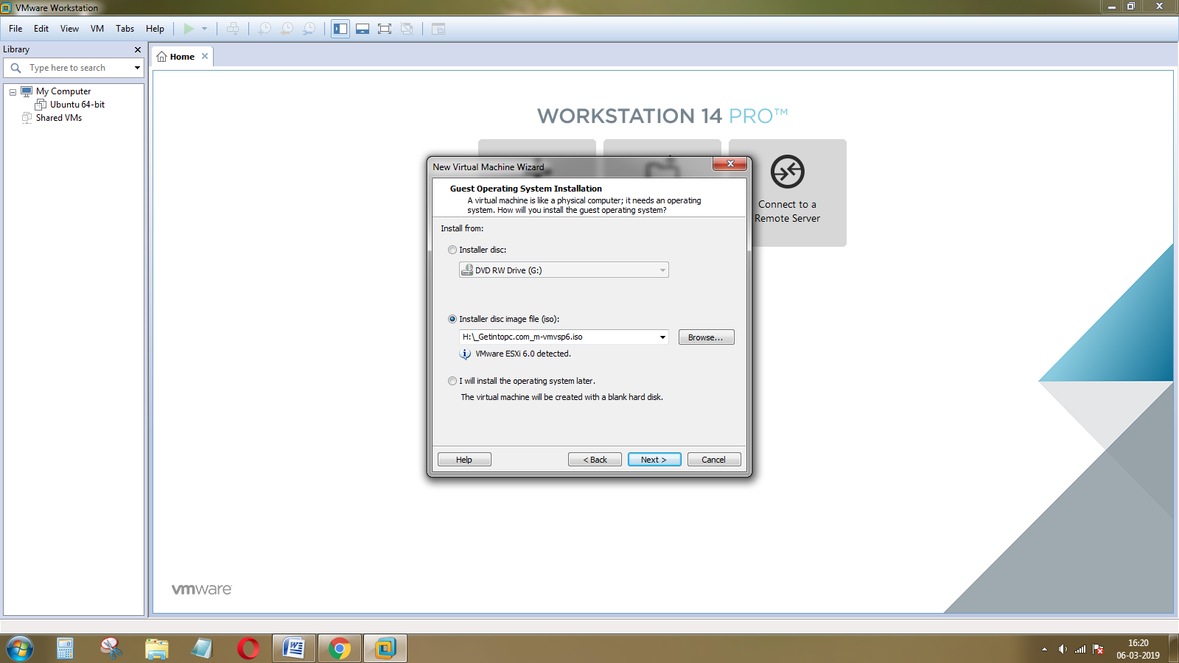

In this step, import the ESXi disk file for installing the ESXi and click on the Next button.

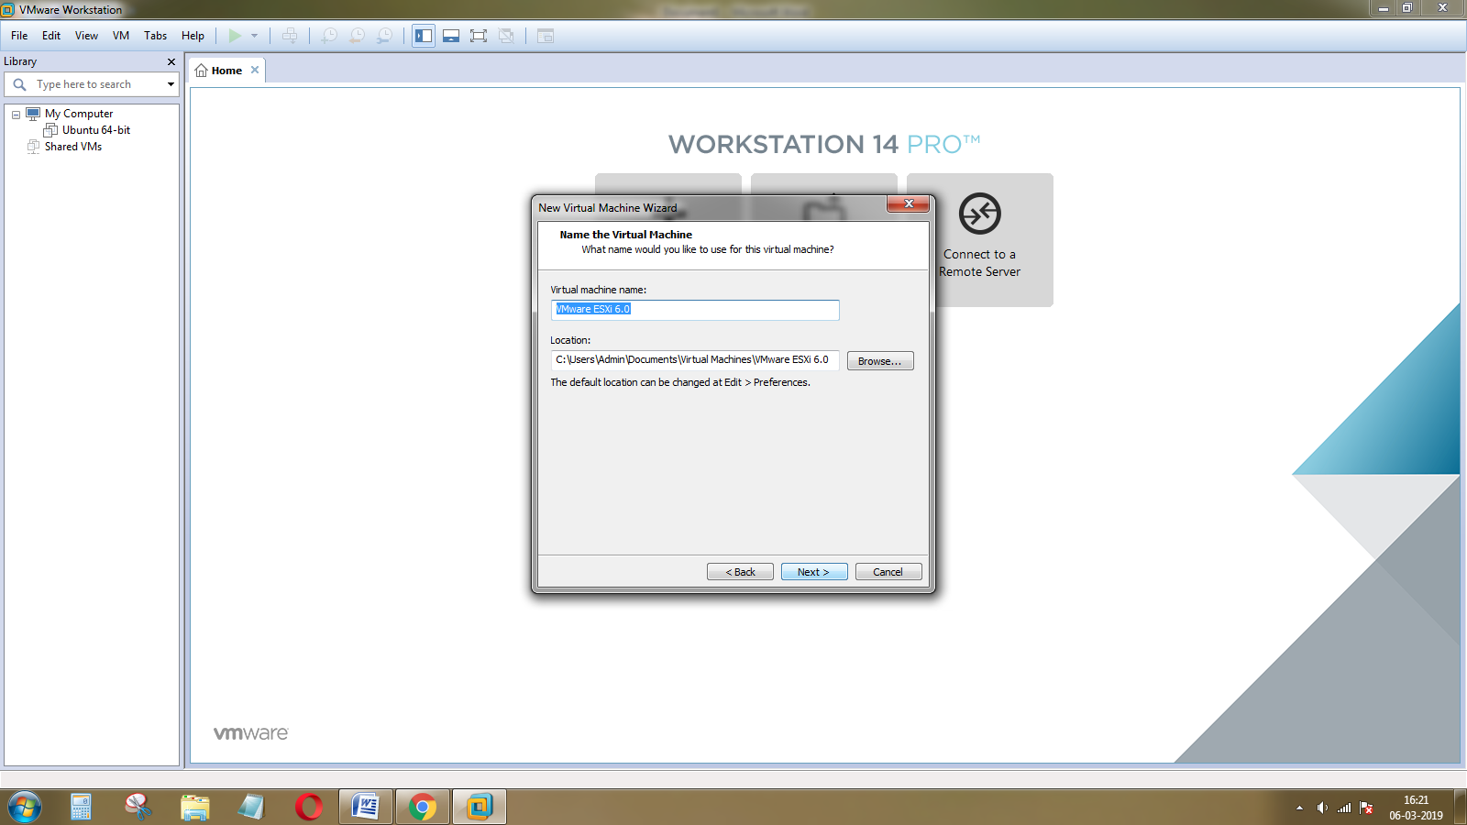

Give the virtual machine and and set the location for the installation, then click on the Next button.

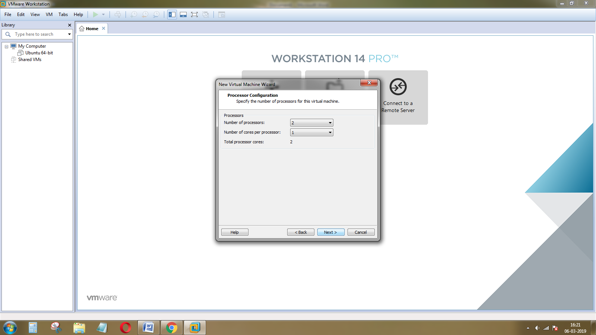

Next, select the number of processors and core processor for the processor configuration, then click on the Next button.

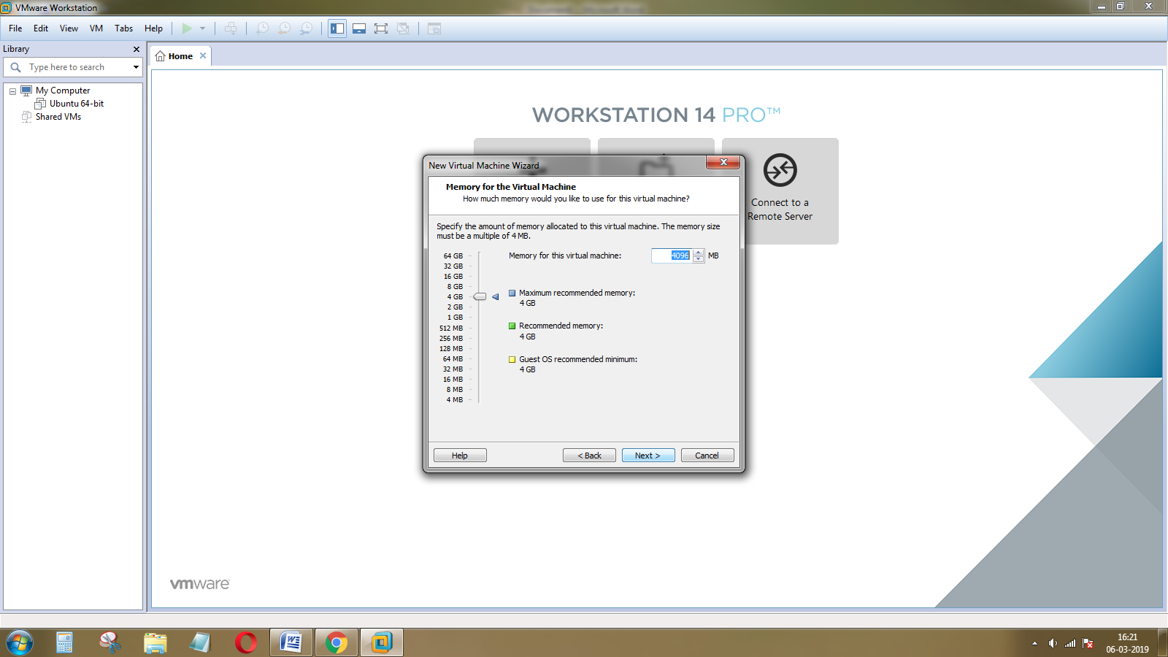

To set the memory allocation for ESXi click on the Next button.

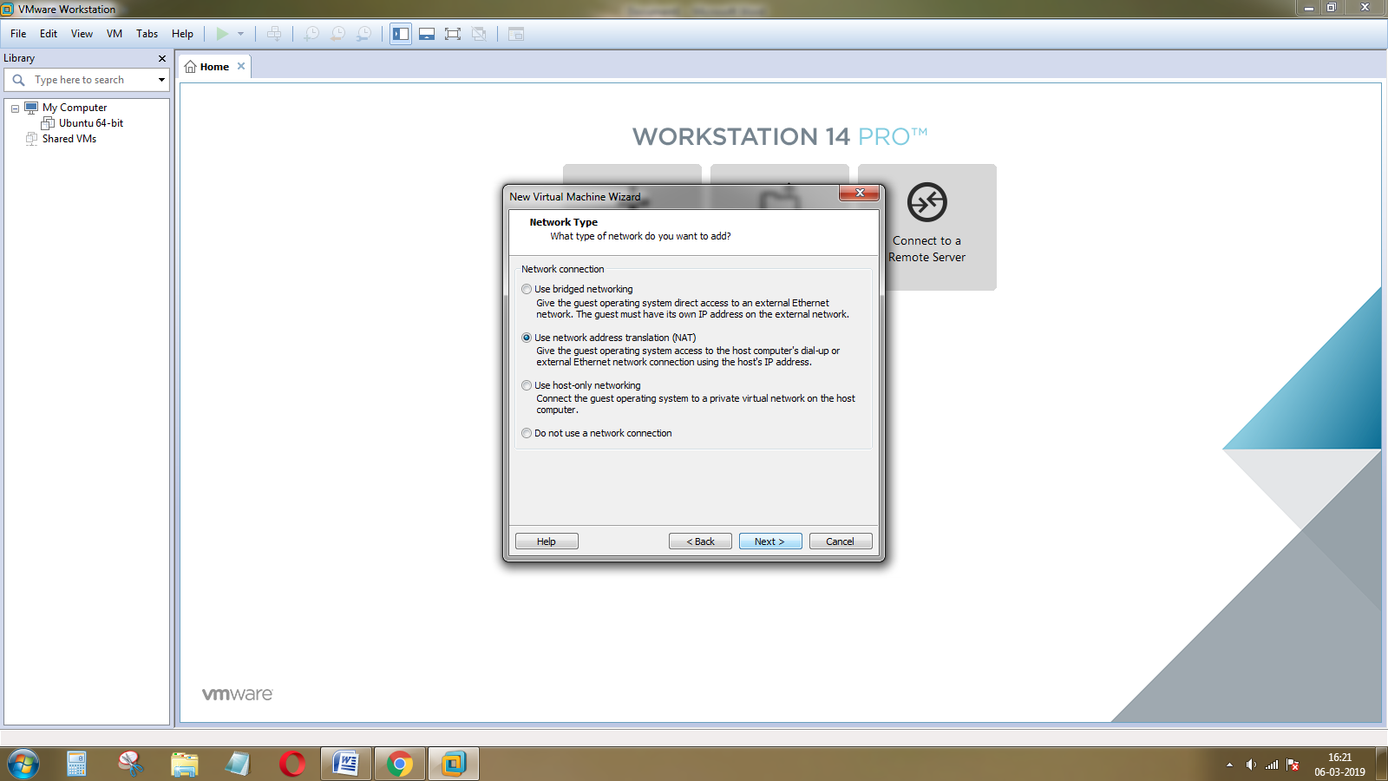

Choose the use network address translation for network type and click on the Next button.

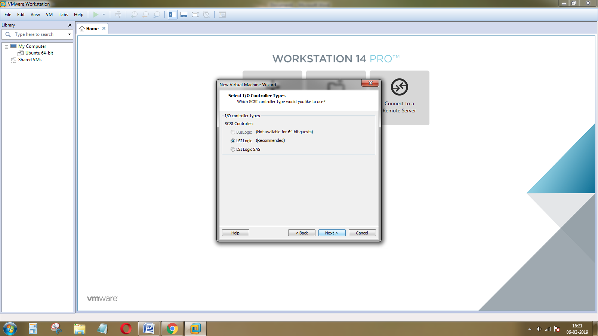

Select the LSI logic for I/O controller and click on the Next button.

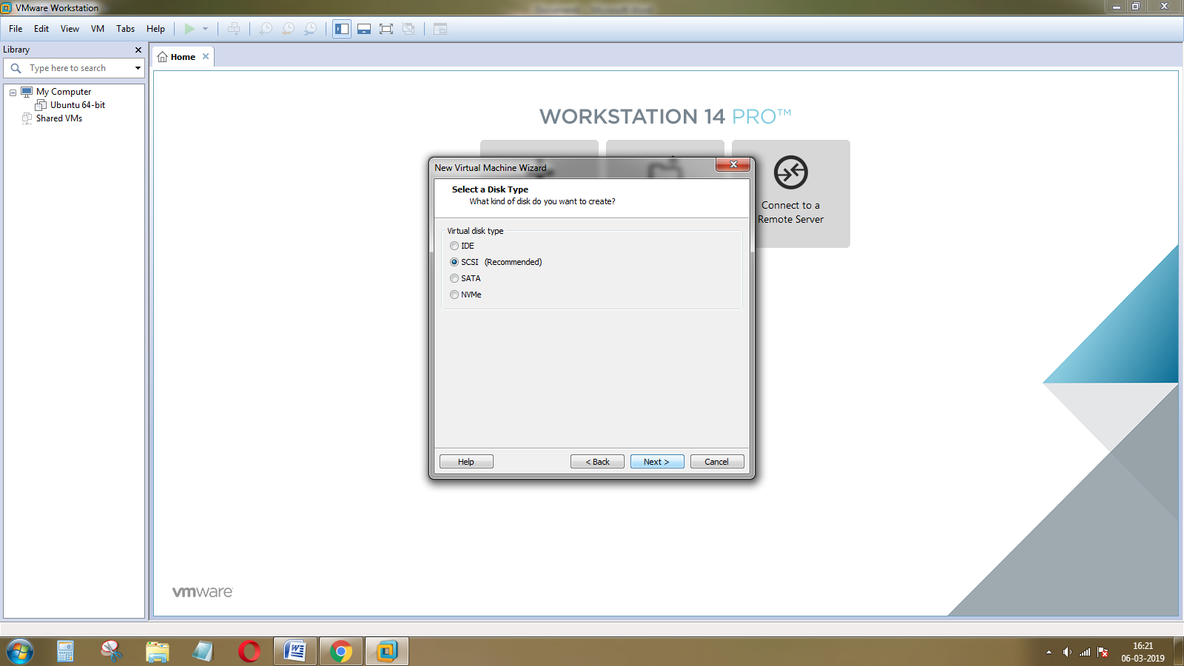

The next step is to select the disk type as SCSI. Then, click on the Next button.

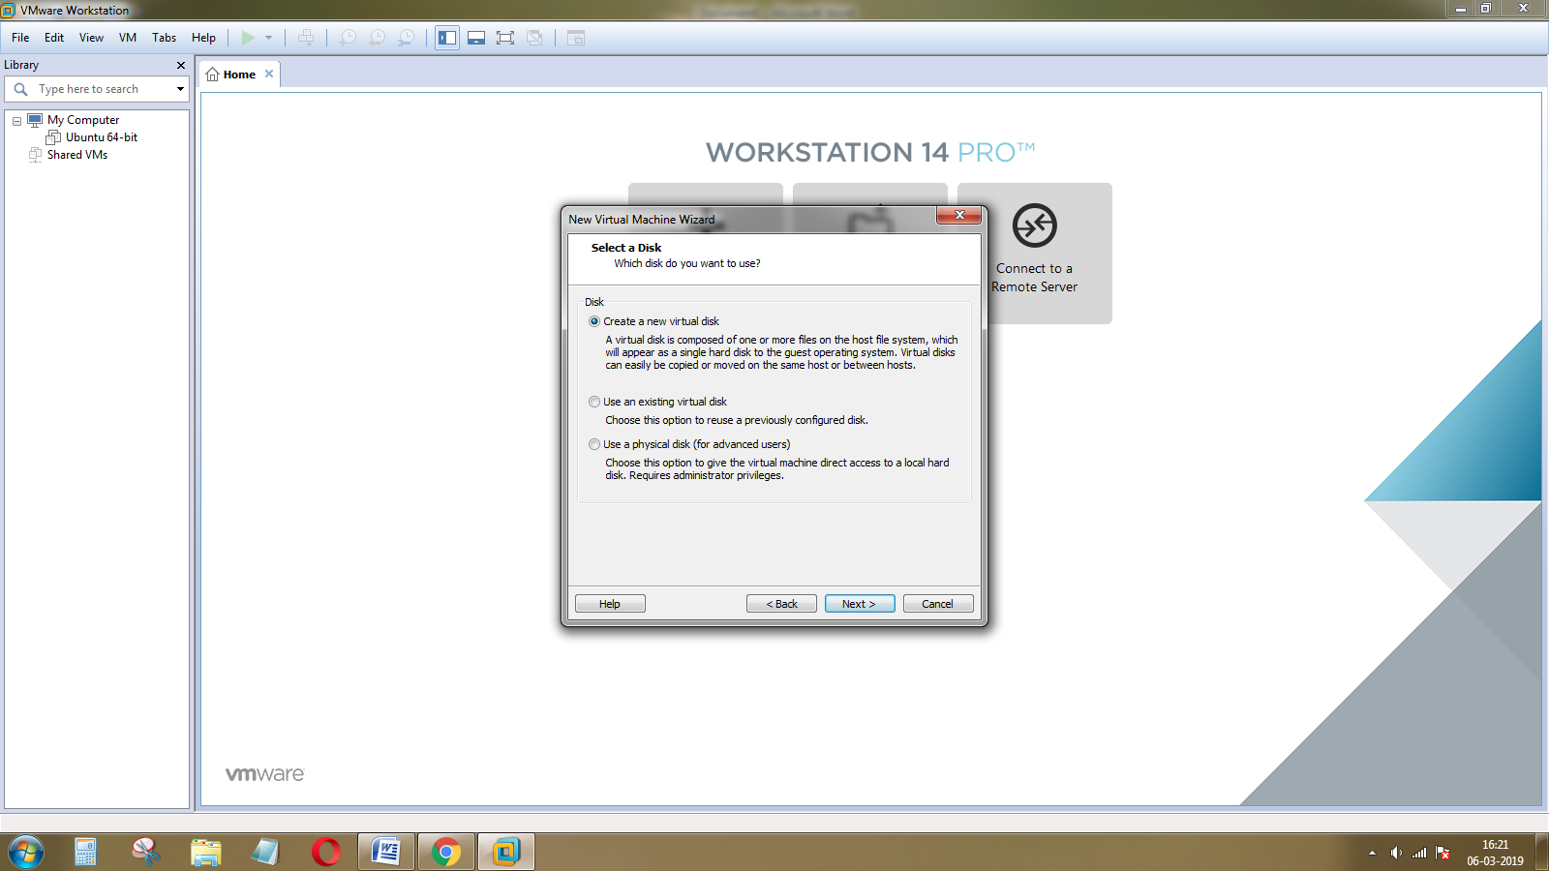

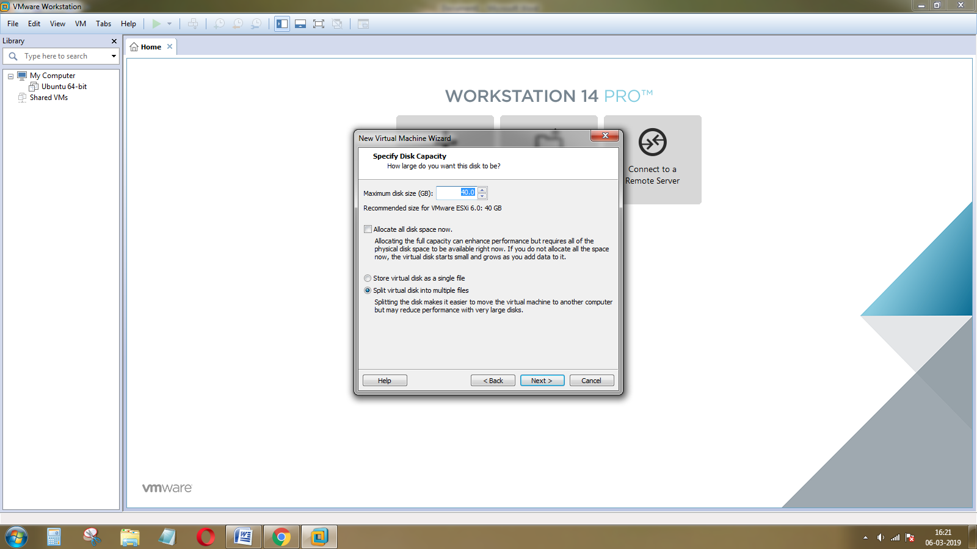

Choose the disk capacity for ESXi installation and click on the split virtual disk as a single file, then click on the Next button.

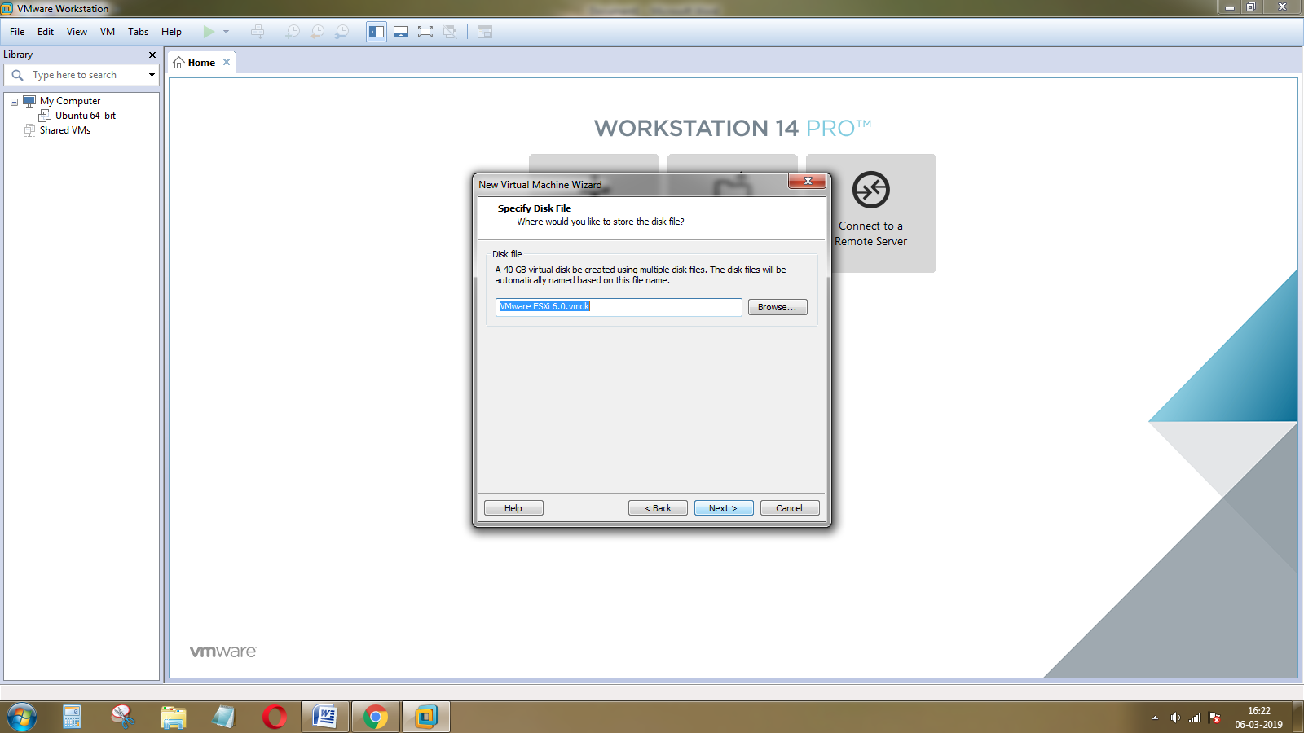

Select the disk file folder and click on the Next button.

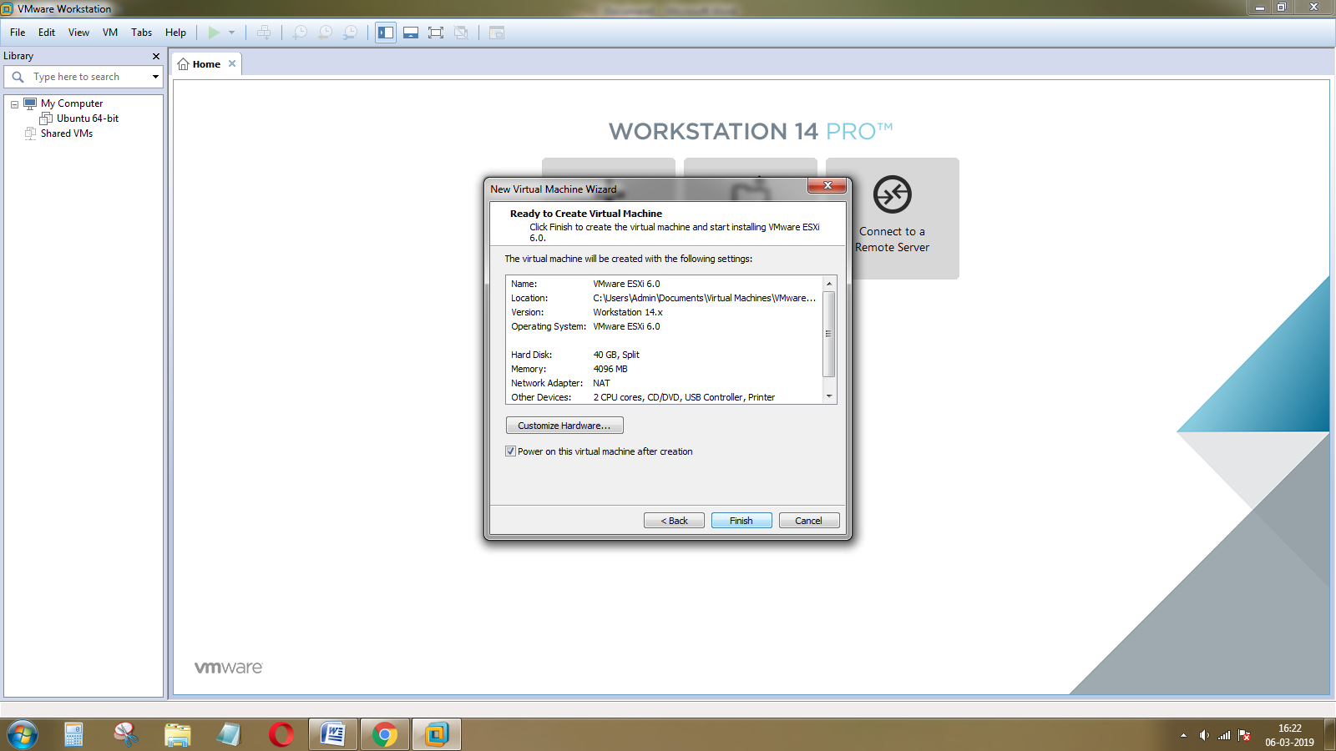

Click on the finish button and the ESXi is installed on the virtual machine.

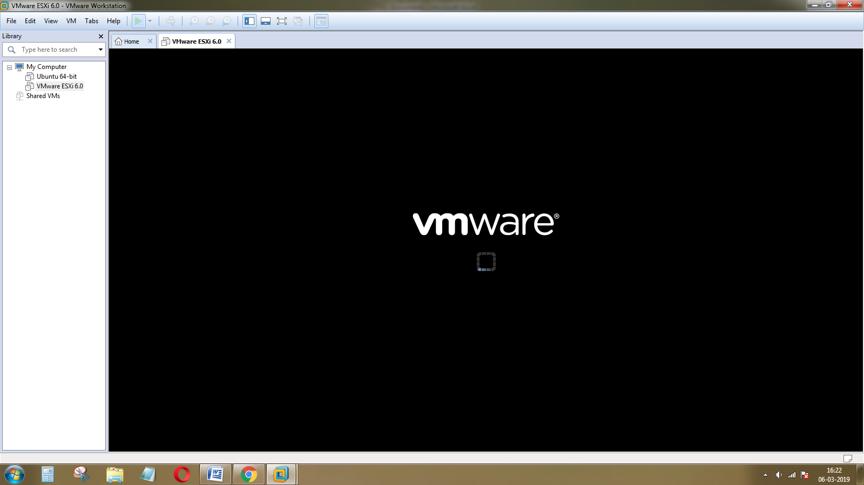

Open the VMware and it displays the ESXi installer.

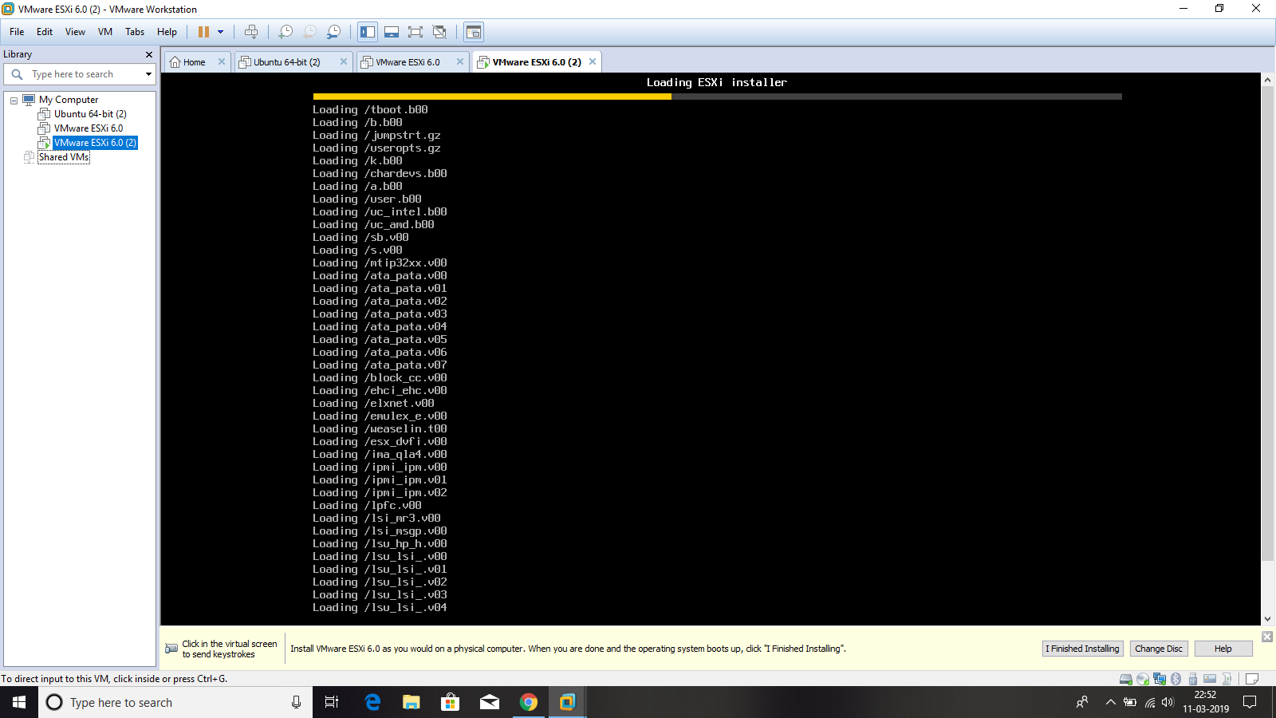

Load the package installer for ESXi.

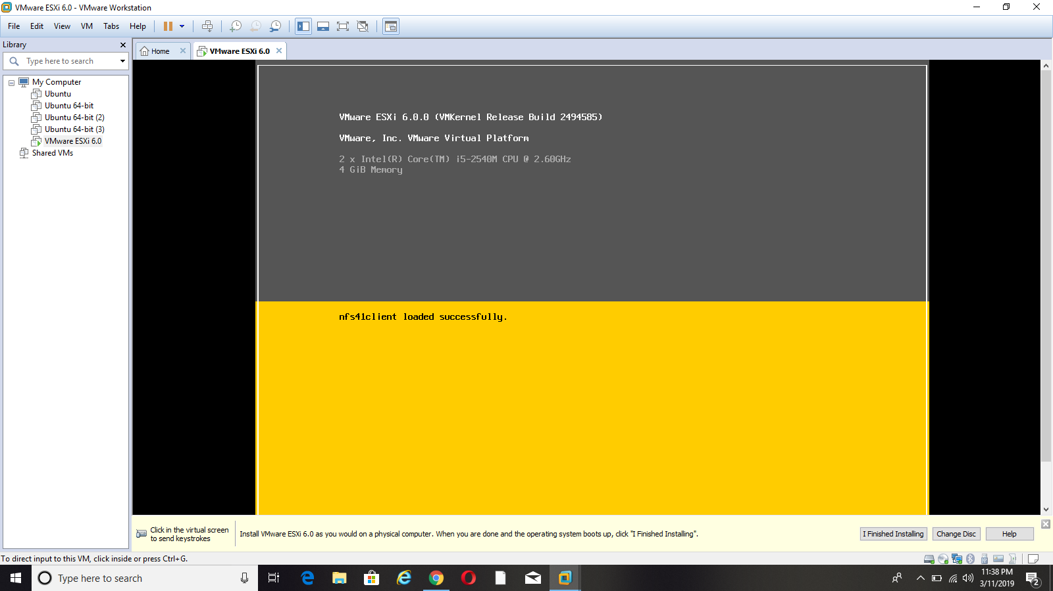

It displays that the client has successfully loaded and then go to the installation page.

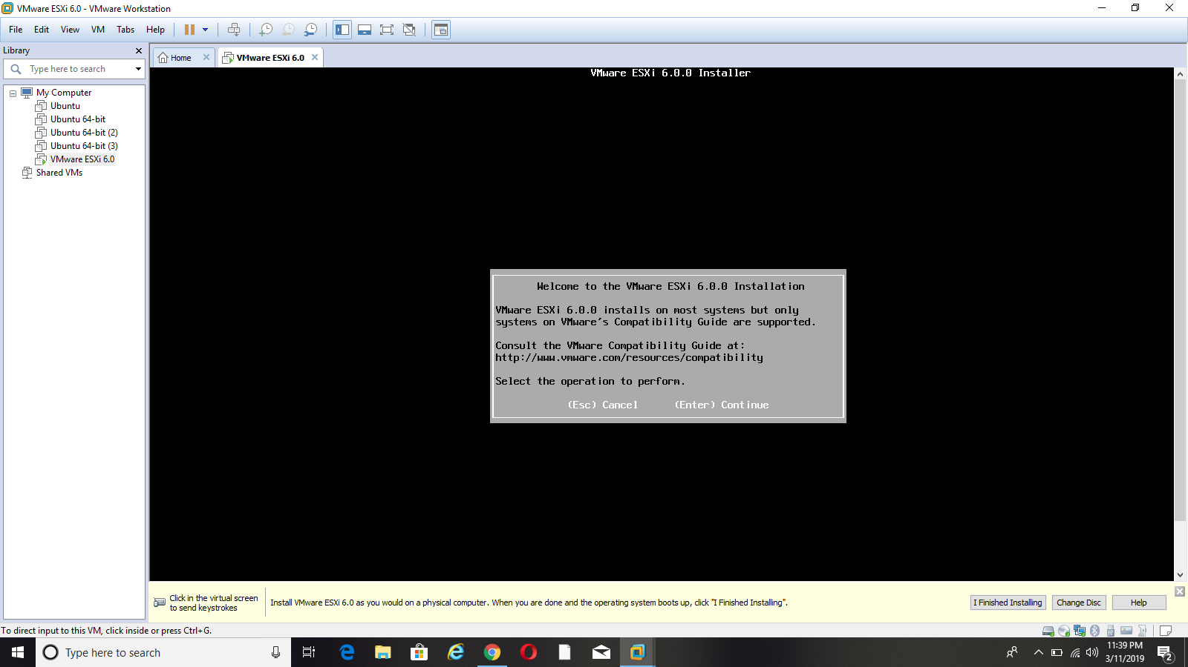

Click on the Enter button for continuing the installation process.

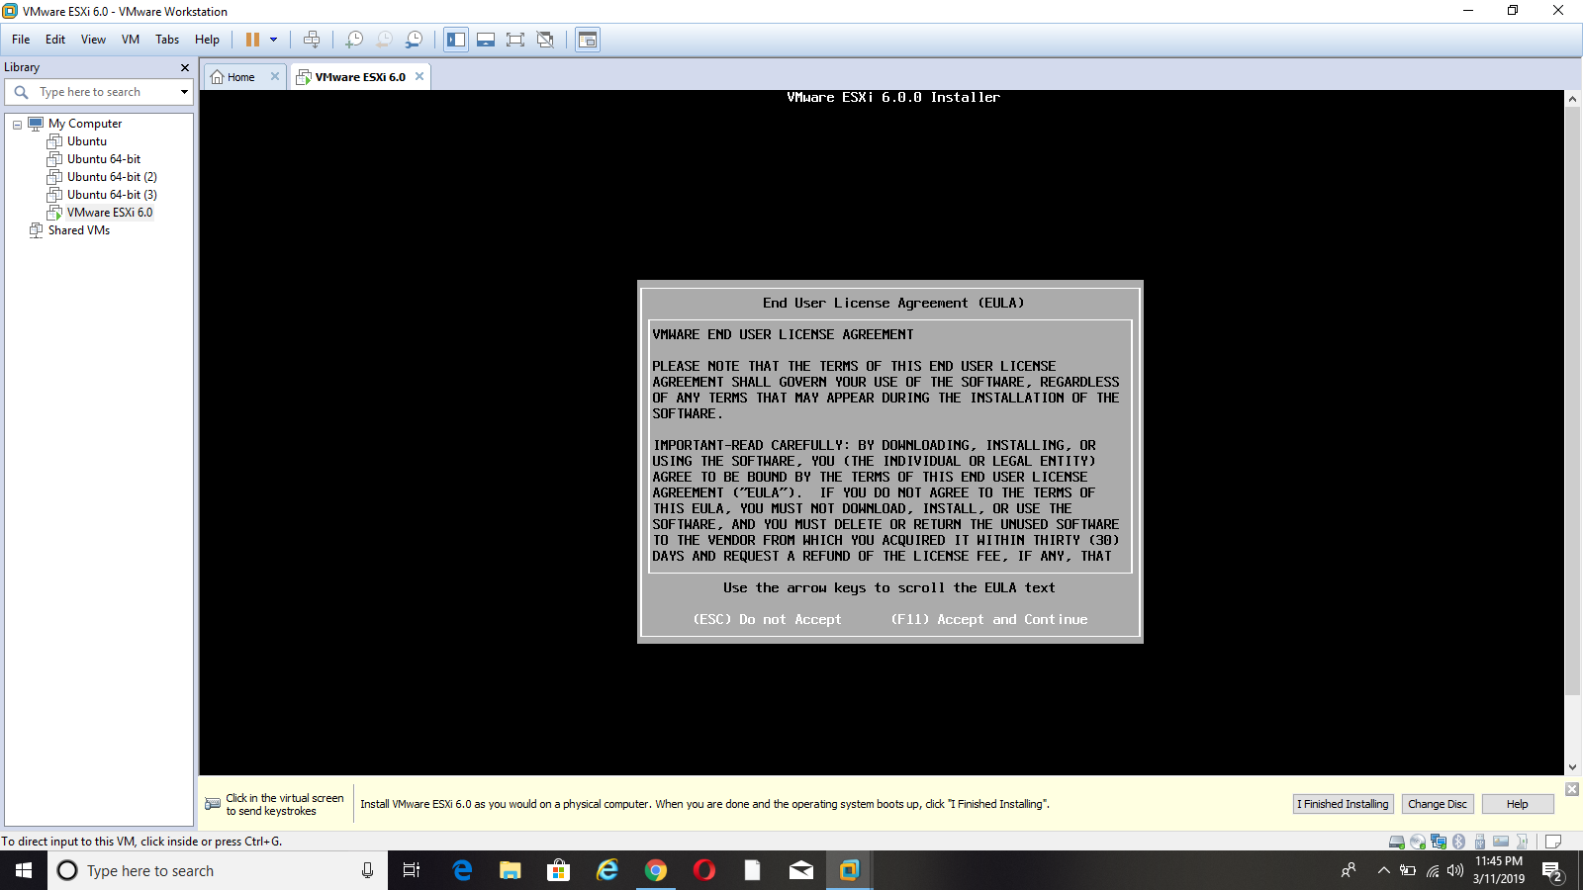

Press the function key F11 for accepting the license for installation.

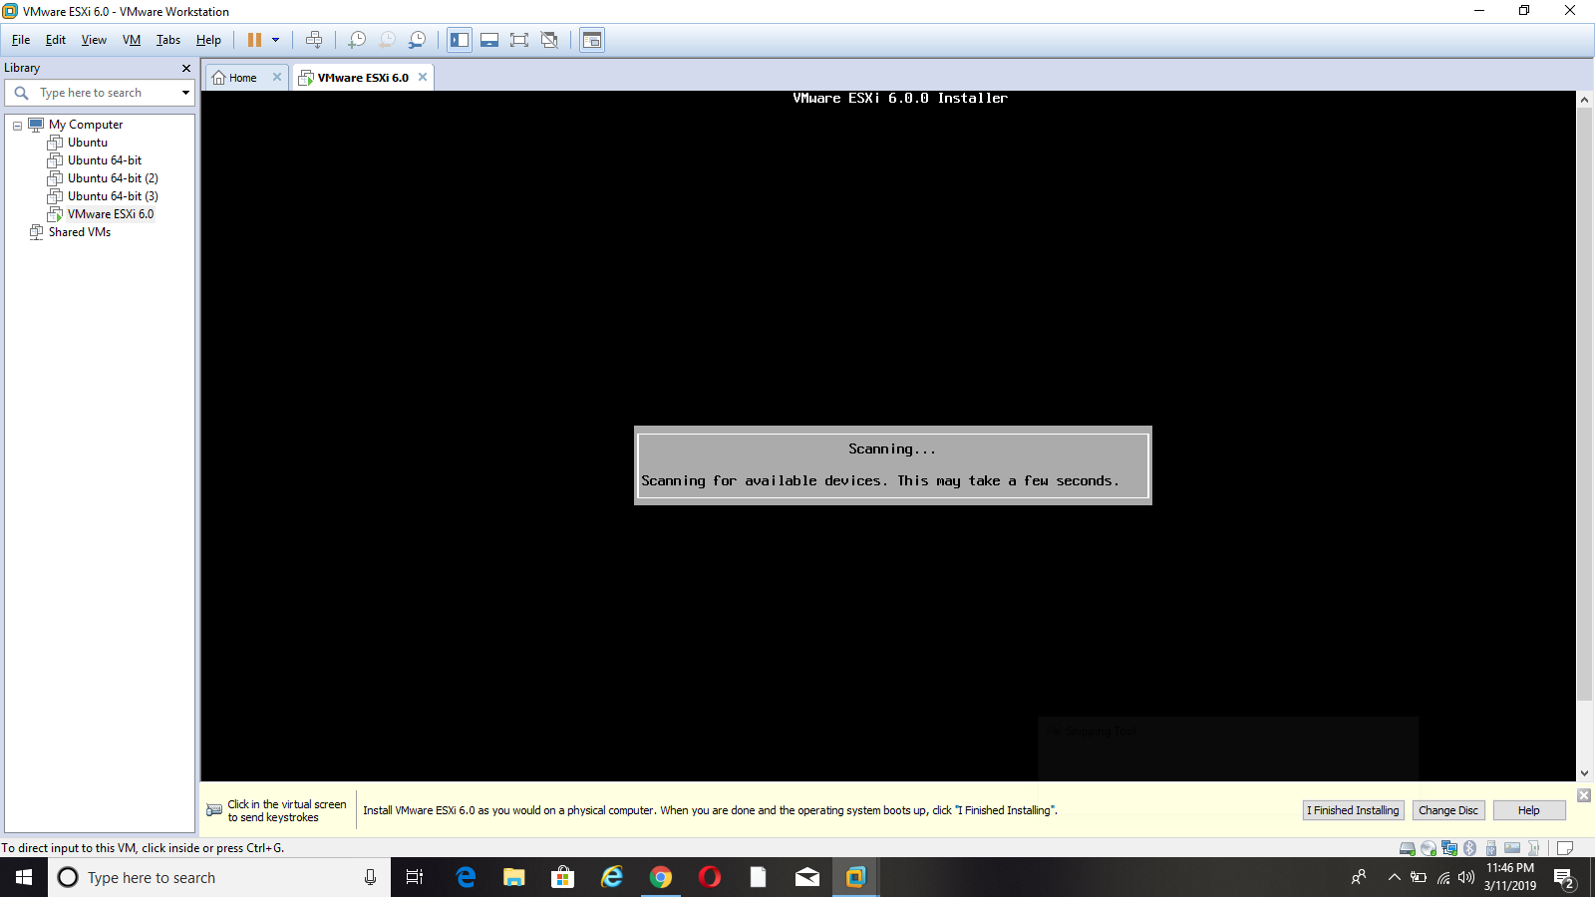

It scans all the files to continue the installation process.

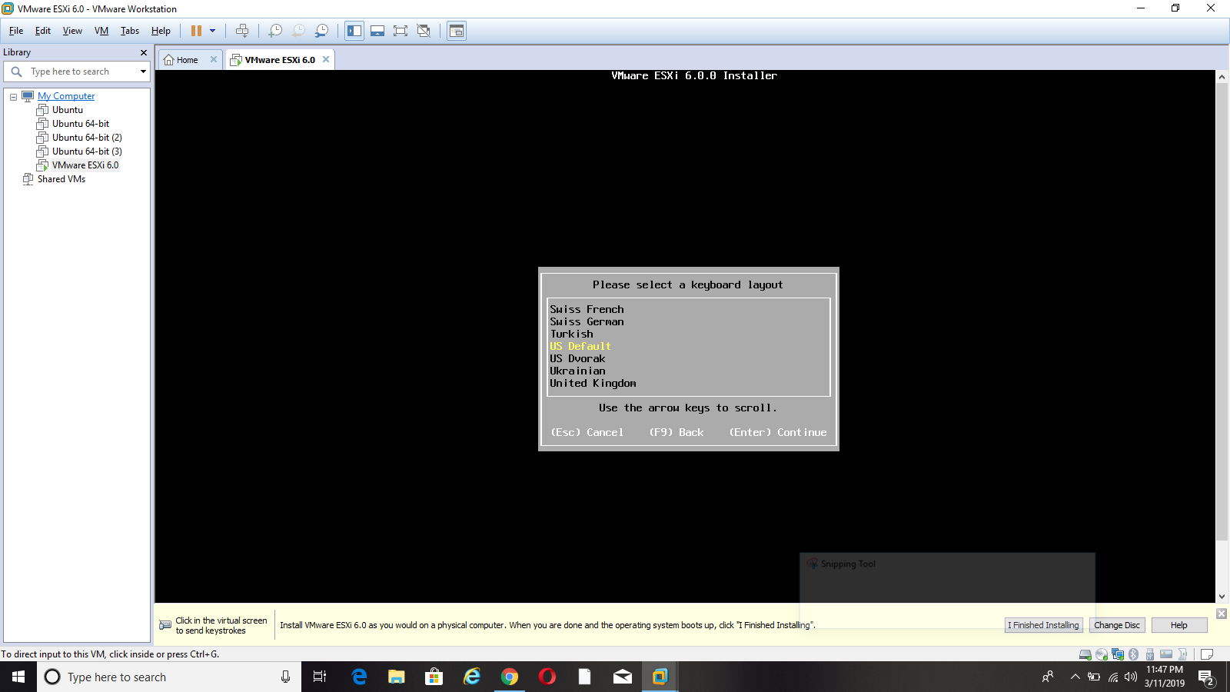

Select the keyboard type as default and press the Enter button to continue.

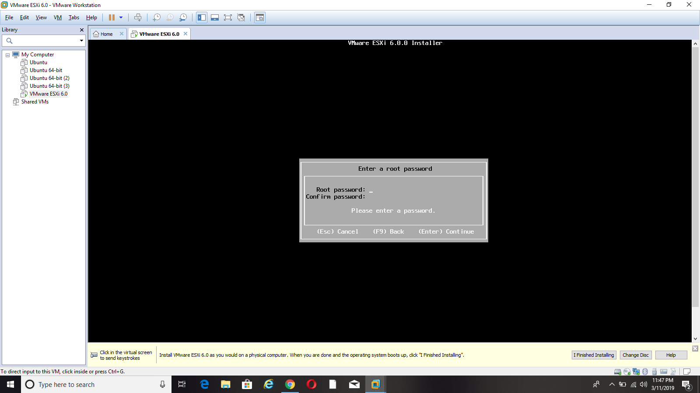

Enter the root password and confirm the password for securing the purpose. Then, press the Enter button.

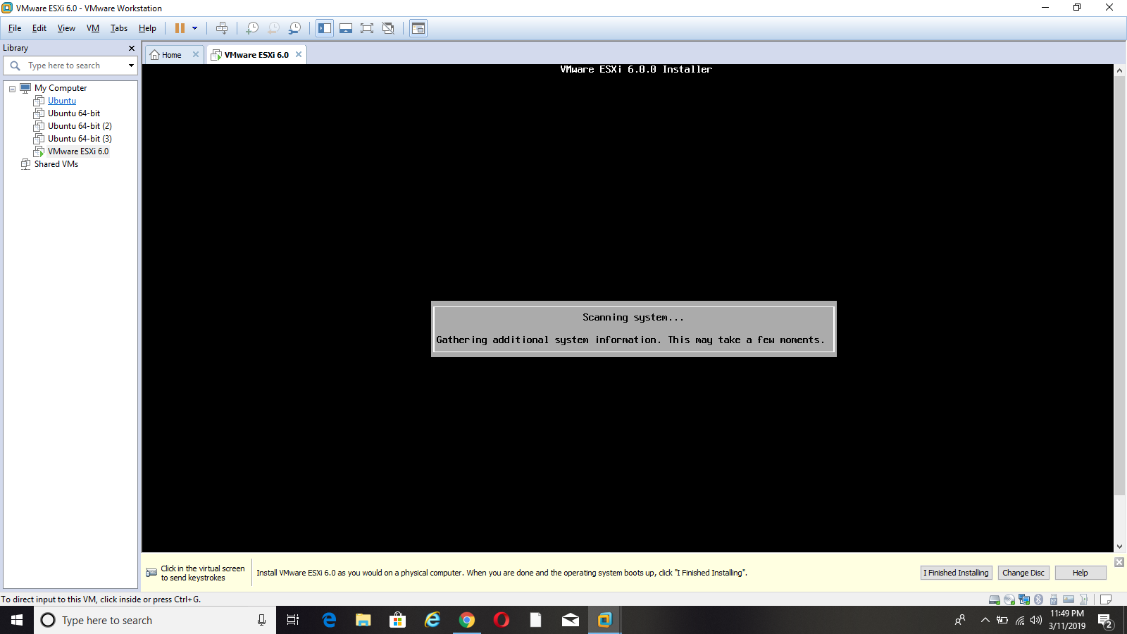

Again, it scans all the files to continue the process.

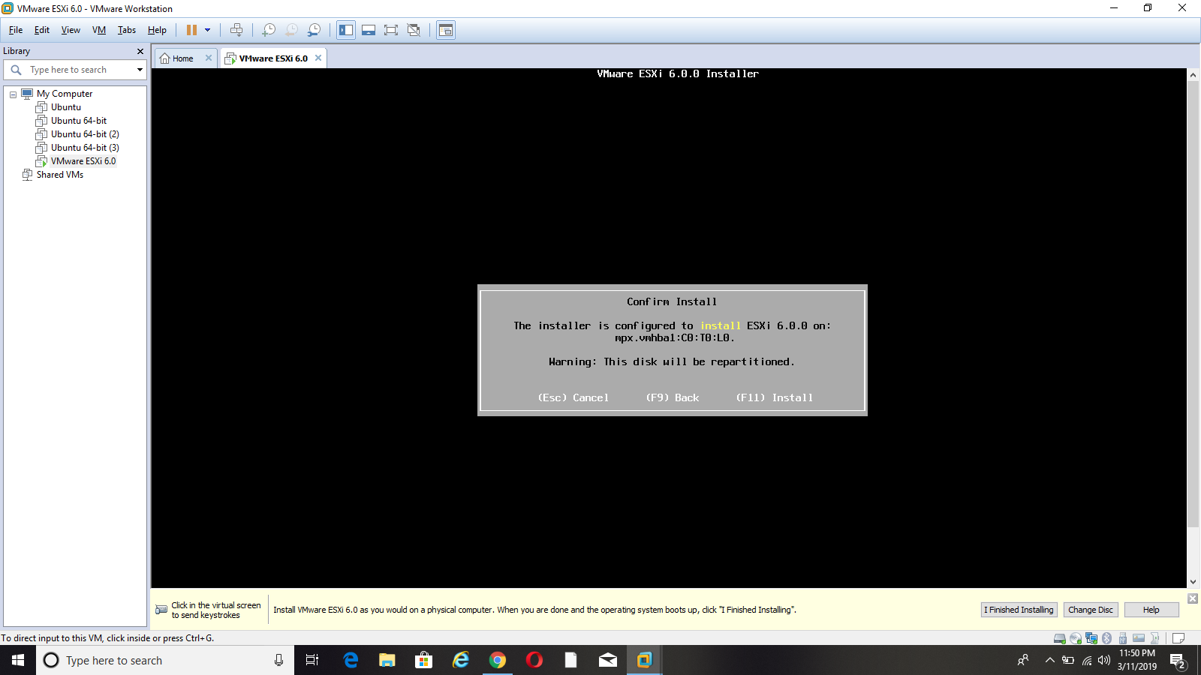

Finally, press the F11 button for installation.

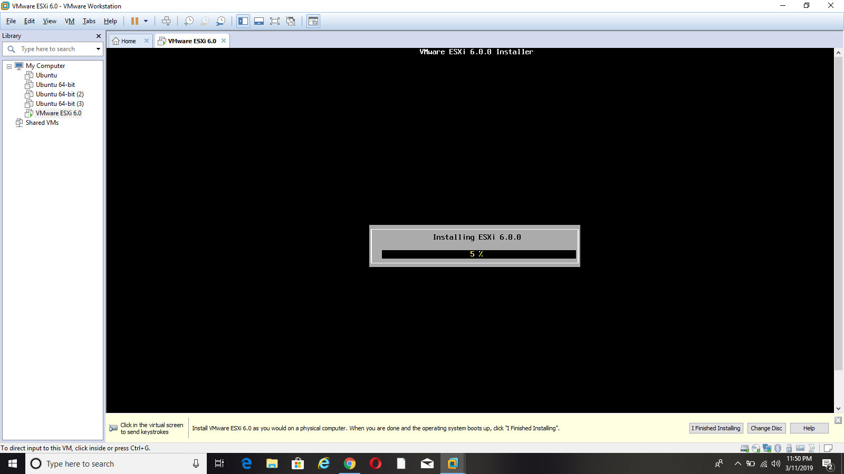

The ESXI is installed and it takes few seconds for installation.

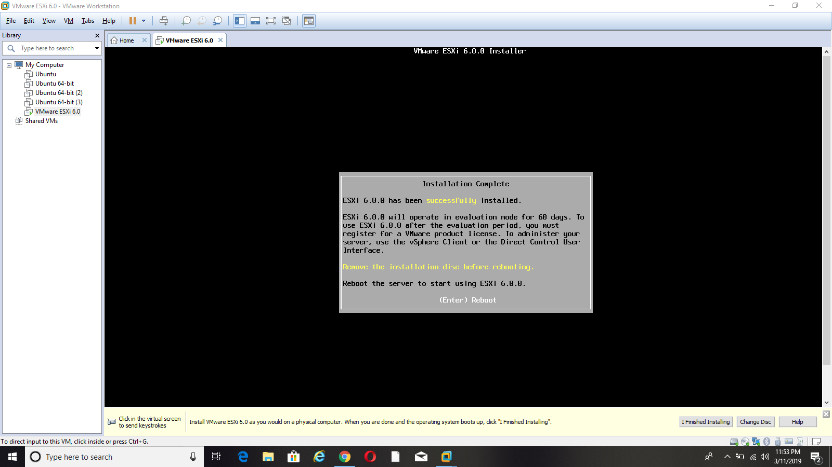

ESXi is successfully installed and click on the Enter button for rebooting.

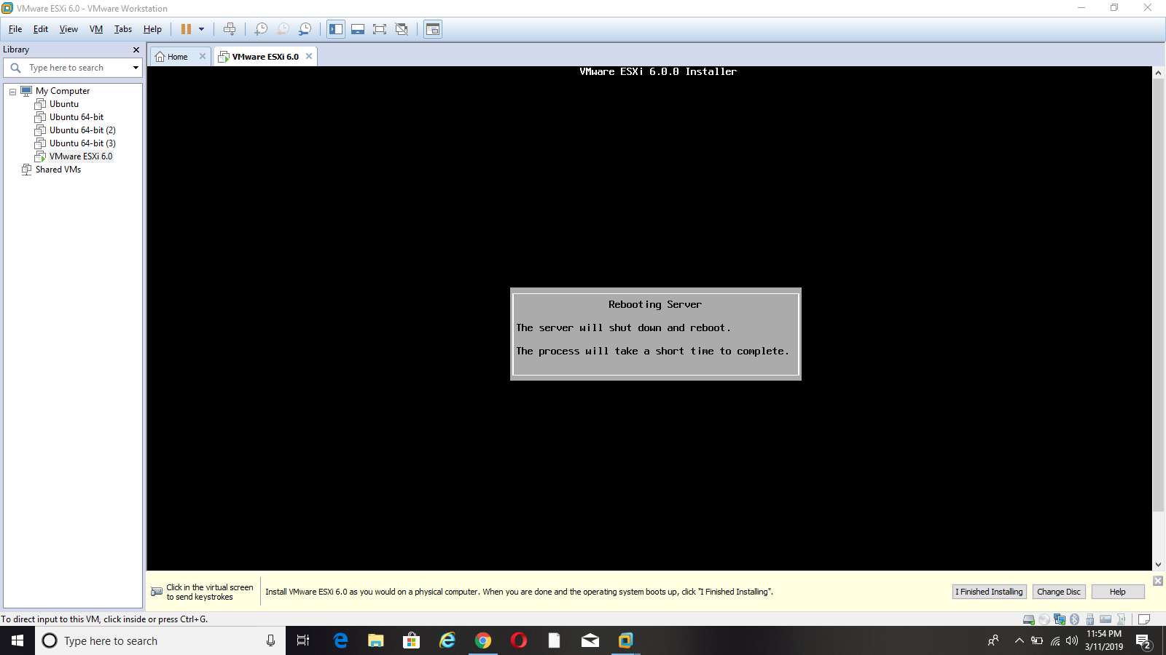

Next, the server automatically will shut down and restart.

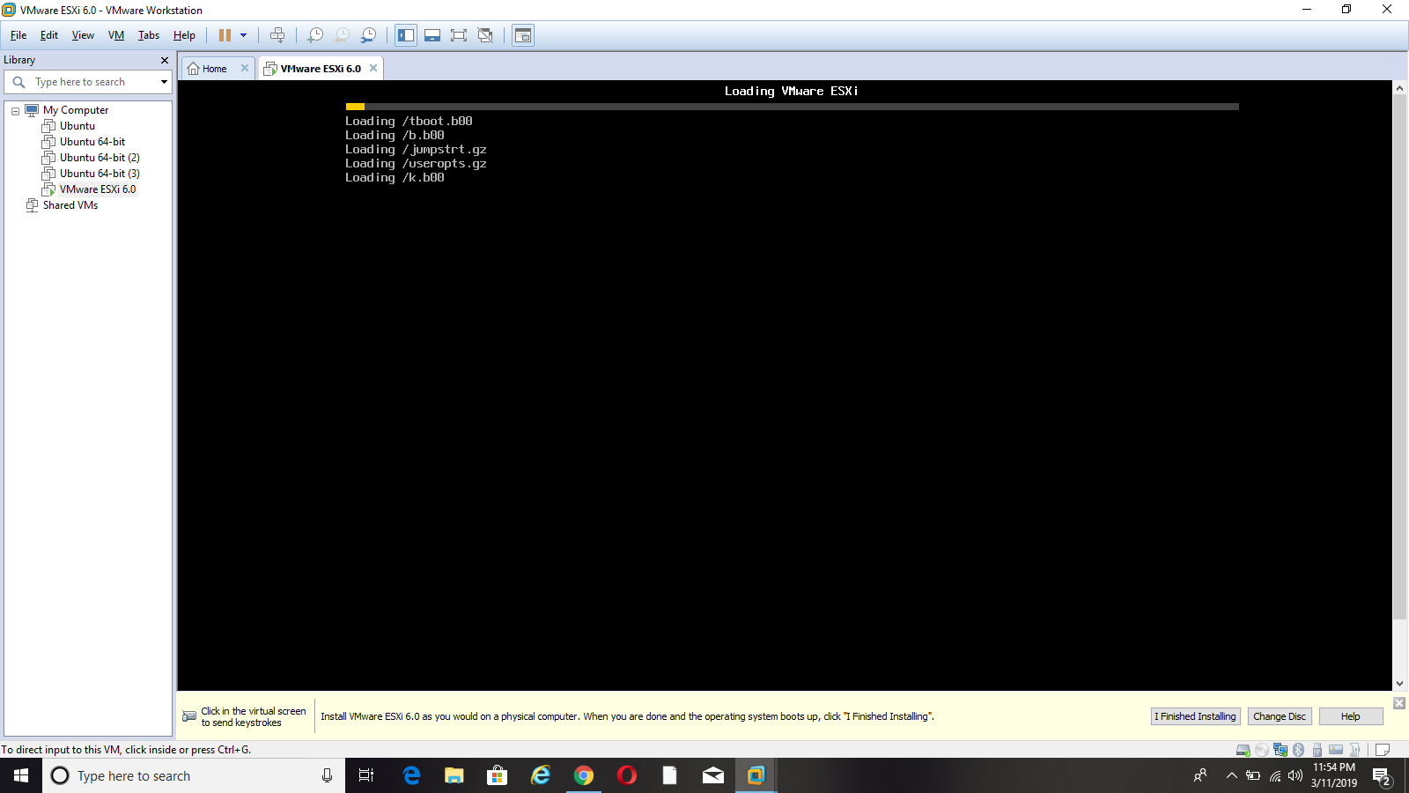

The ESXi VMware loads and it opens as shown below.

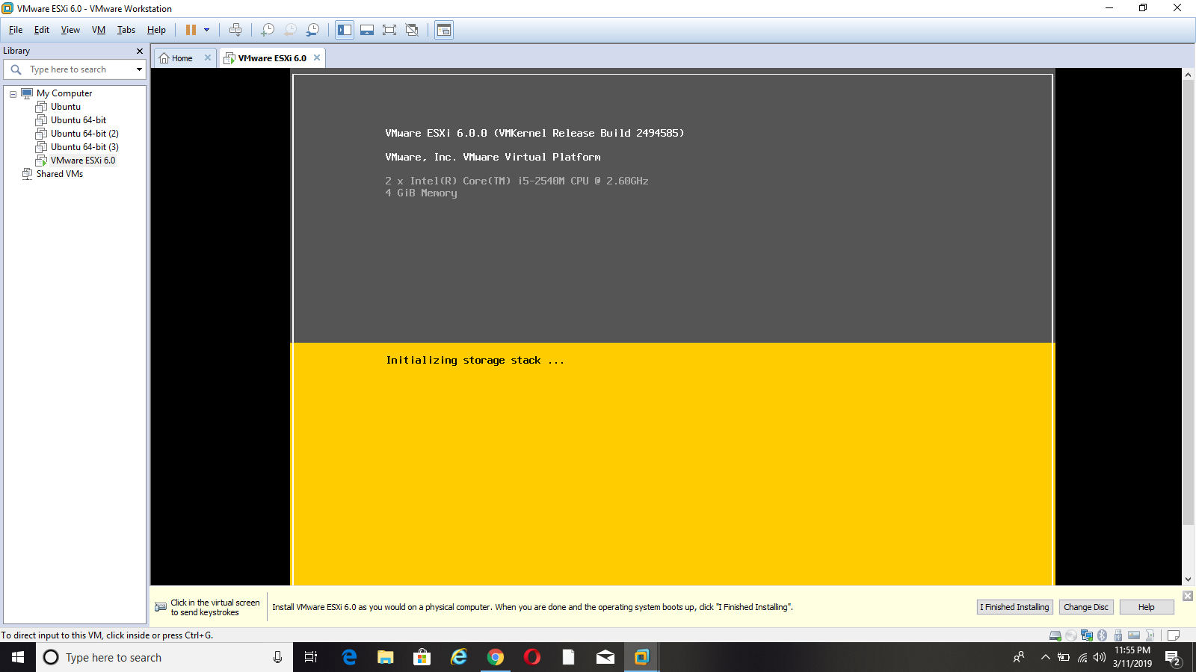

The ESXi VMware opens and it displays the IP address for configuration.

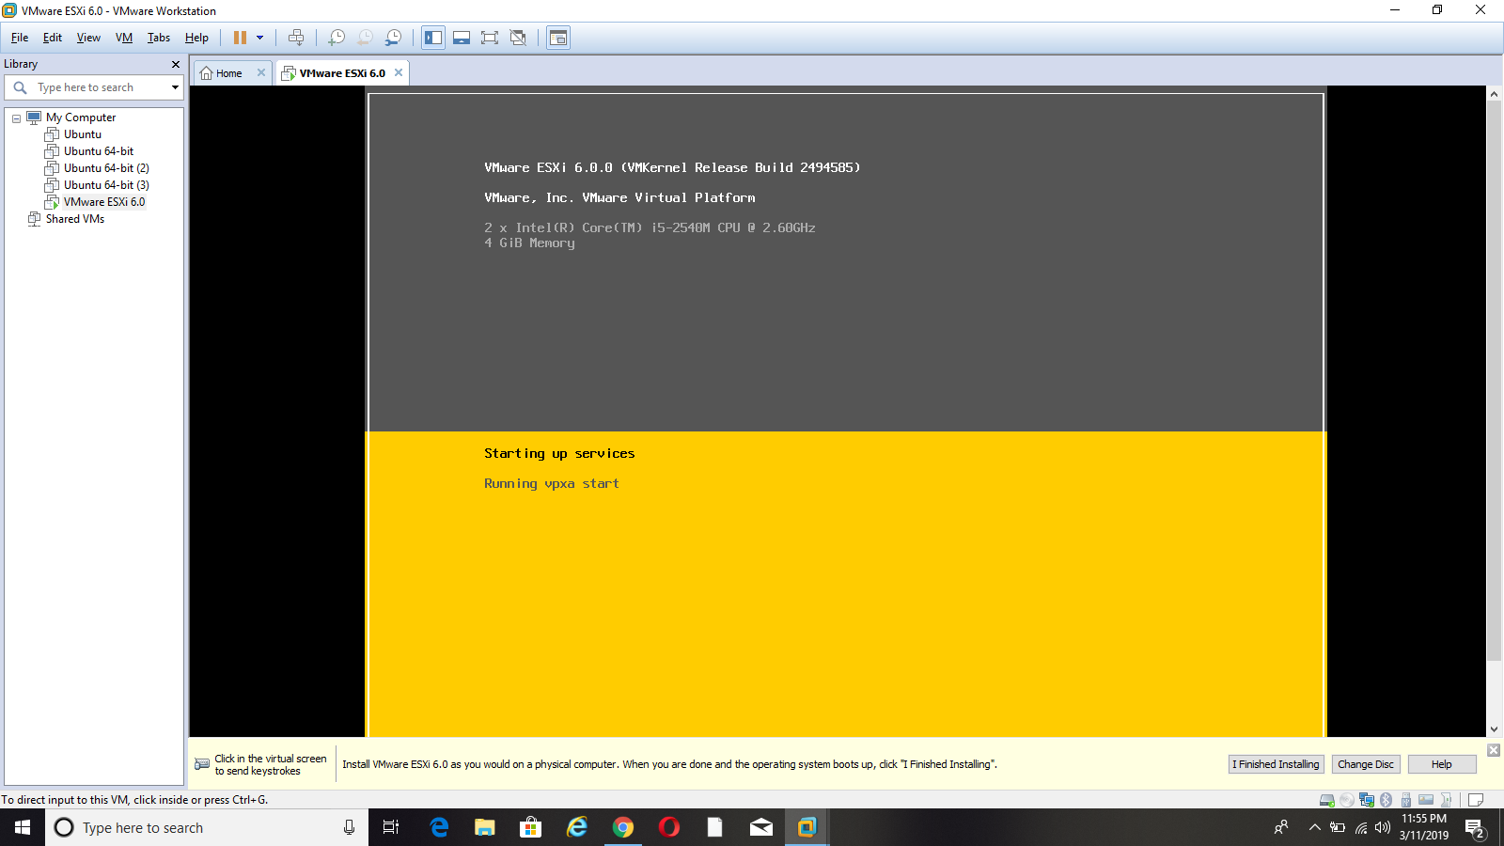

The IP address is loaded for host configuration.

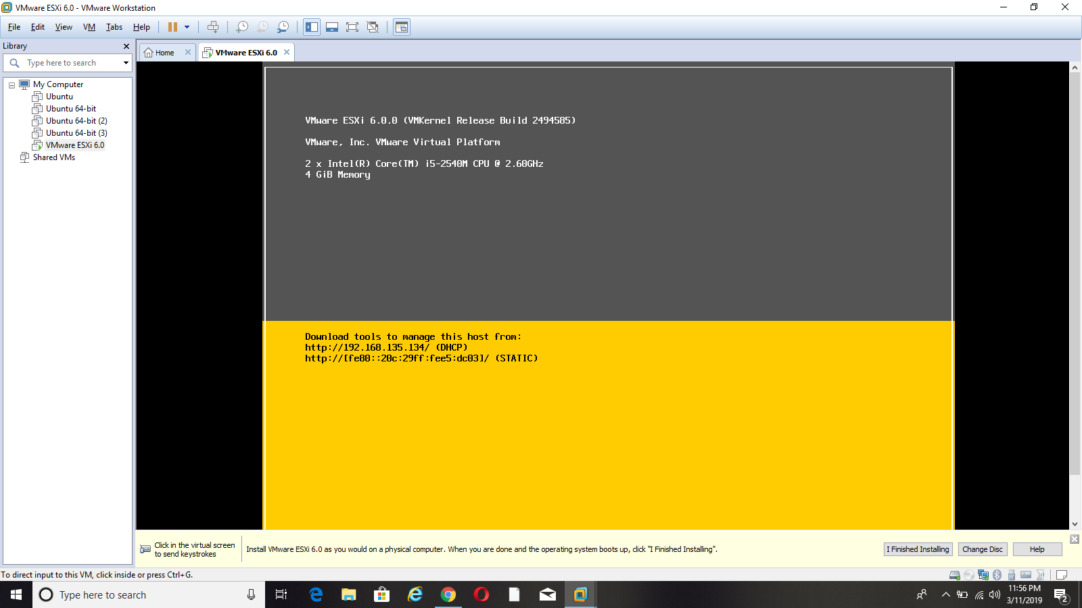

The ip address is used to configure the host.

# Task 2: Configure an ESXi Hosts

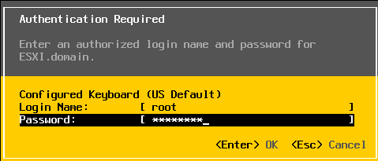

Click on F2 button for network settings and it displays the login name and password. Enter the login name and password.

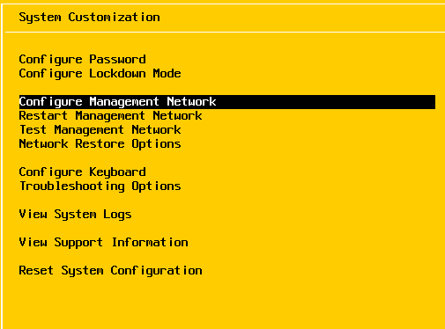

It goes to the system customization page for host configuration and selects the configuration management network.

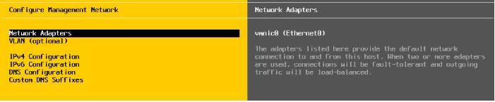

Press the Enter button and it goes to the configure management network page. Then, select the network adapters and click on the Enter button.

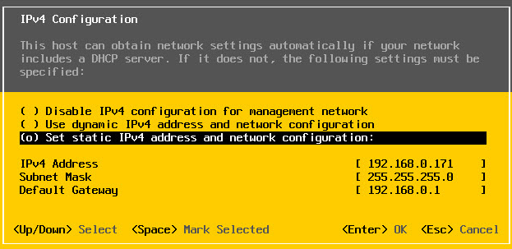

This IPV4 configuration fills the IPV4 address for your server, subnet mask and default gateway. Next, click on OK.

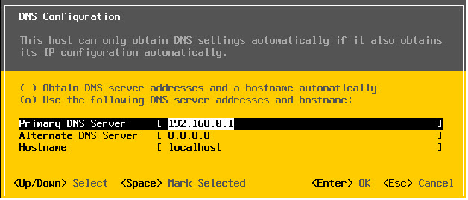

Then, connect the DNS and check the DNS serer address. Then, click on the ESC key to back to windows.

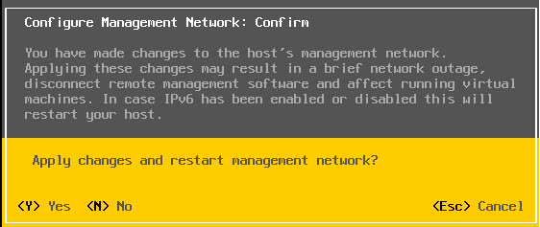

After configuring the host, press on Y for restarting the management network.

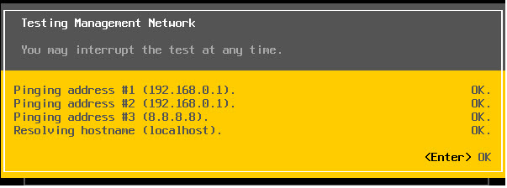

It testing all the addresses and it opens the host address.

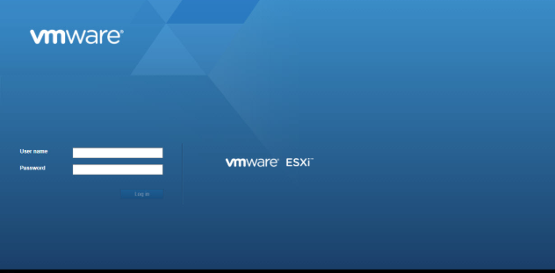

The ESXi VMware successfully opens. Then, enter the user name and password.

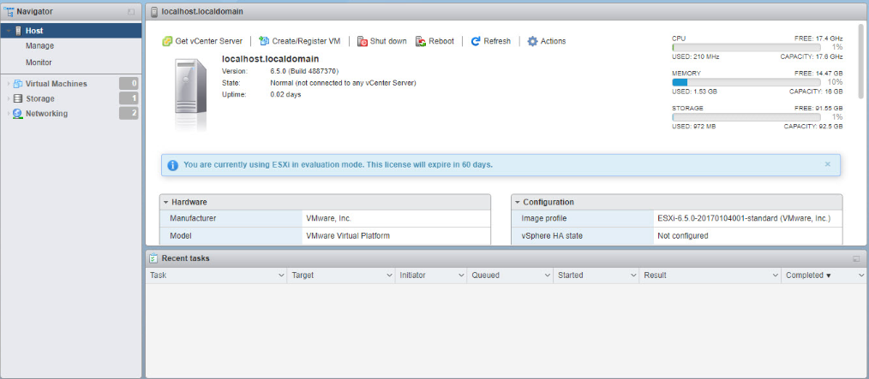

It displays the local host configuration.

# Task 3: Examine the ESXi Host Hardware Configuration

The first step is to install the Vsphere client in ESXi. Enter the IP address in the URL page. This displays download Vsphere client ("VMware vSphere 4 - ESX and vCenter Server", 2019).

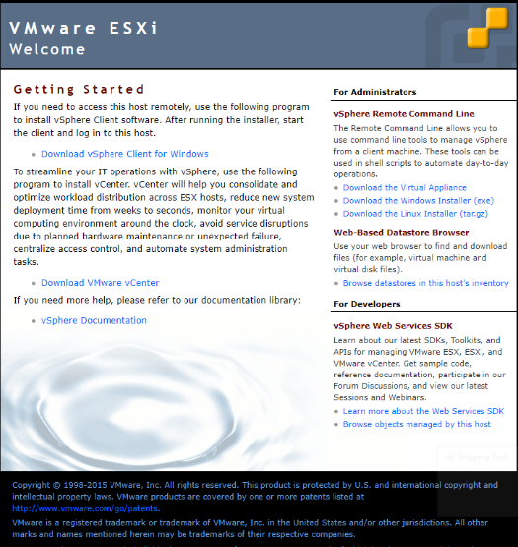

Click on download vSphere client for windows link and download vSphere client.

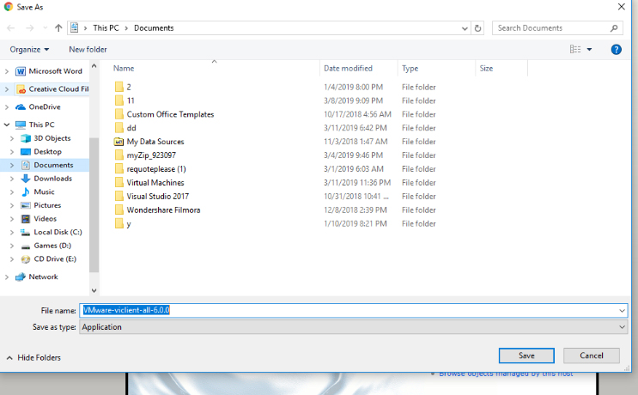

Download Vsphere for VMware and extract all the files.

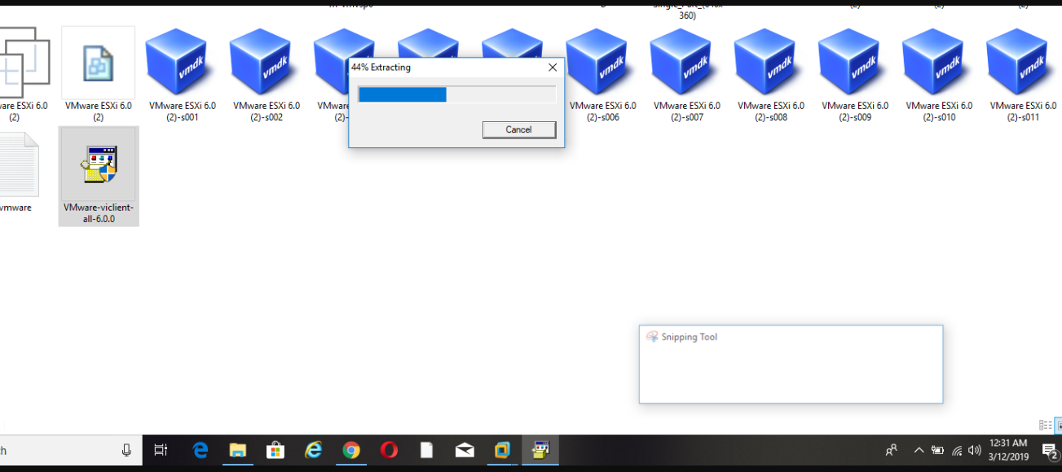

To extract it take few seconds.

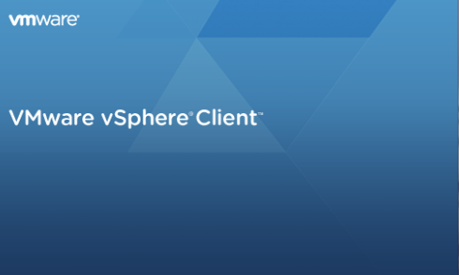

VMware vSphere client is an automatic pen and it installs the other necessary packages.

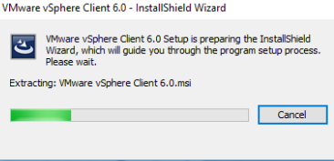

It take time for extracting the files.

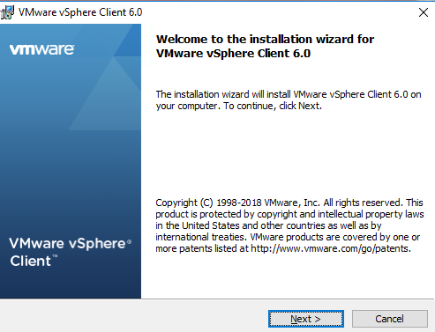

The installation page opens and then click on the Next button.

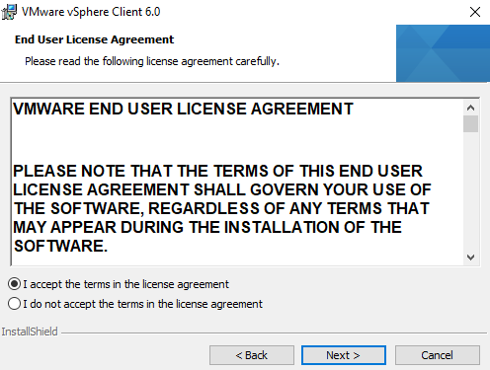

Accept the license for installation and click on the Next button.

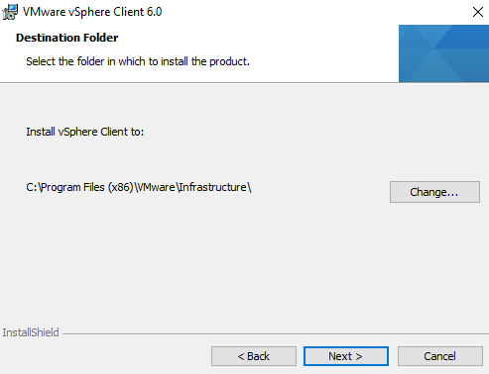

Select the folder for installing the client and click on the Next button.

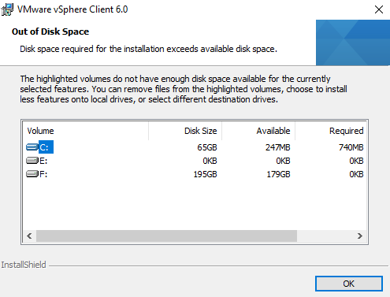

Click on Ok button and select the folder for installation.

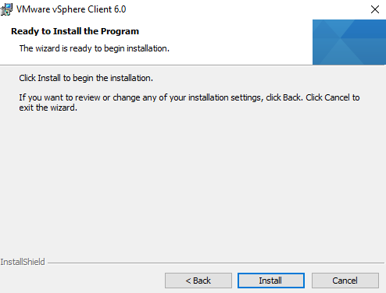

Click on the Install button for installing the VMware vSphere Client.

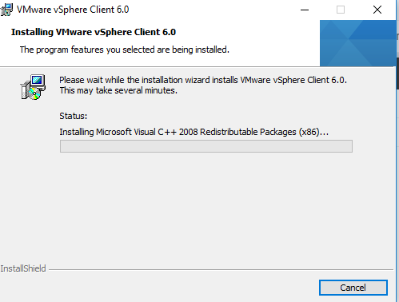

The packages are installed and finally click on the Finish button.

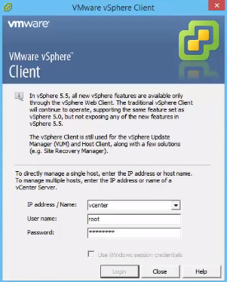

Login to the VMware vSphere client by using TP address or name, user name and password, then click on the Login button.

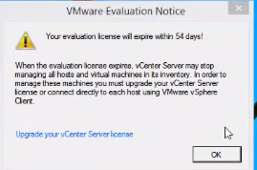

It displays the expired notification then click on Ok button.

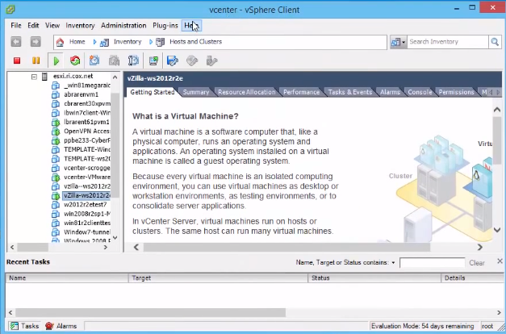

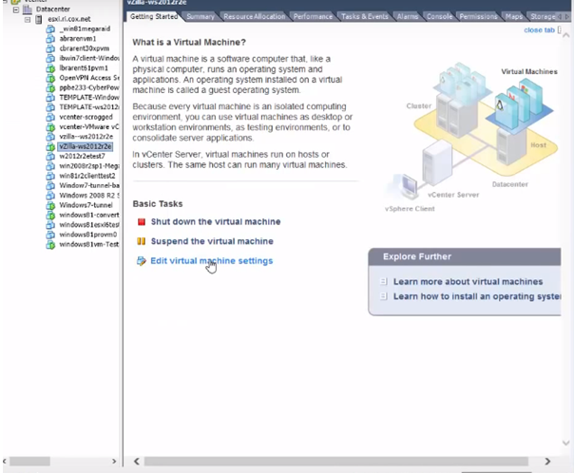

To check all the data center settings and to set the disk space click on the Edit virtual machine settings.

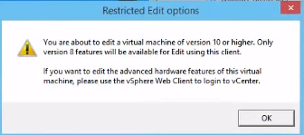

It shows the restricted edit options for hardware configuration, then click on the Ok button.

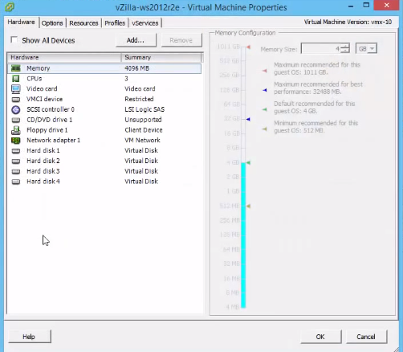

Click the hardware property and check the memory allocation, CPUs, video card and check the hard disk space, then click on the Ok button.

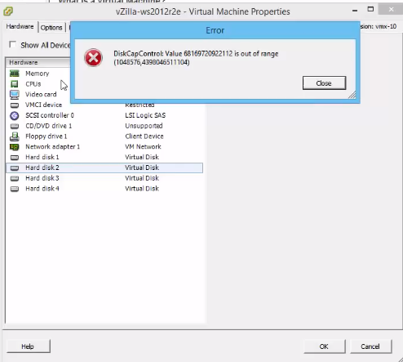

The hard disk 2 has out of range memory space, so check the next hard disk space.

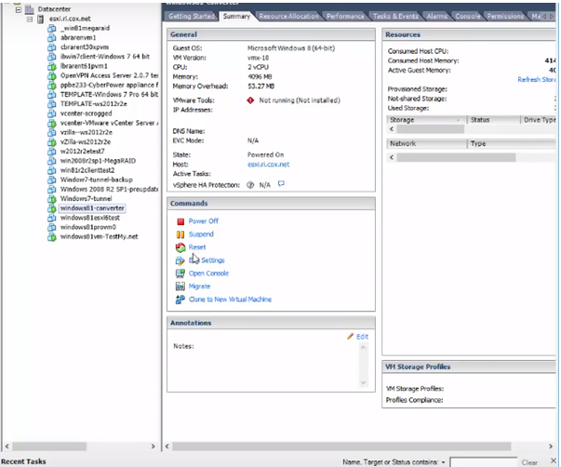

Check the windows converter summary for hardware configuration and click on the Edit settings.

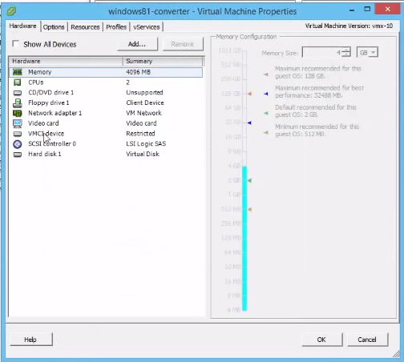

It displays the hardware and hardware summary for allocating the memory.

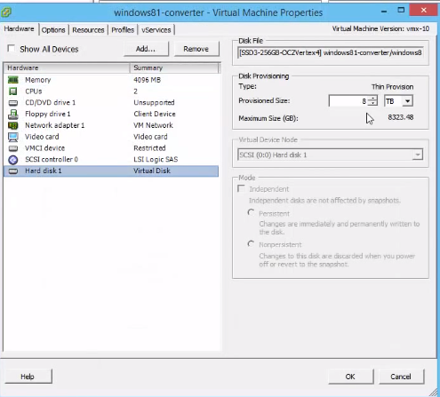

Check the provisional size and change the size from GB to TB, then click on the Ok button.

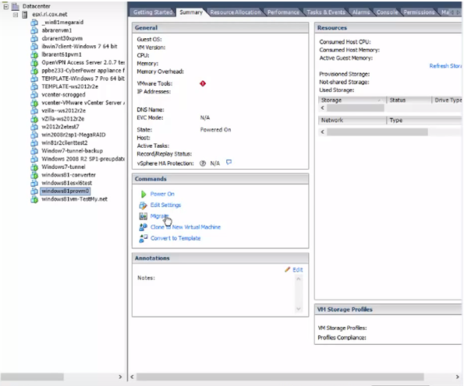

Next, check the hardware details for the window provm and click on the Edit settings button.

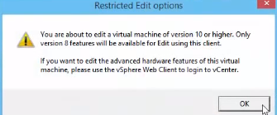

It shows the restricted edit option for the hardware and click on the Ok button.

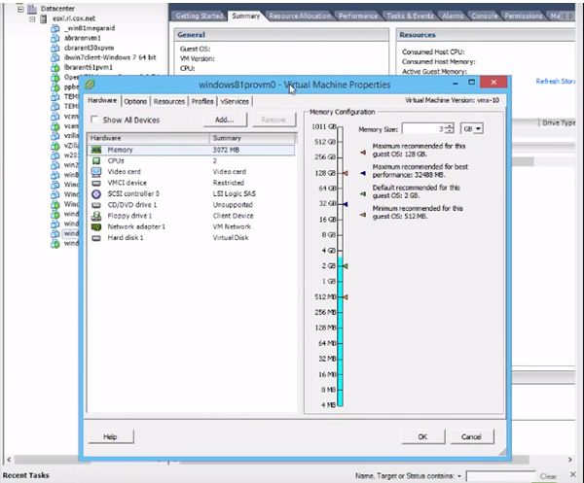

Change the memory size for memory configuration and click on the Ok button. Then, click on the CPU option and click on Add button for adding the hardware.

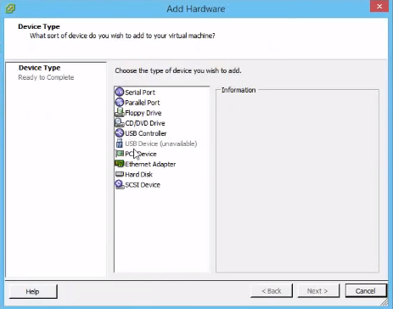

It shows the add hardware page and check the hardware type. Then, click on the hard disk option and click on the Next button.

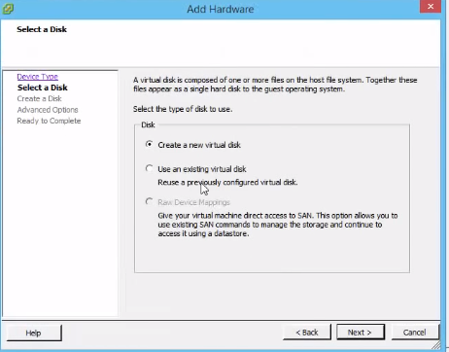

Second, select the disk to add the hardware. It displays create new virtual disk option, existing virtual disk option and device mappings, then choose Create new virtual disk option. Next, click on the Next button.

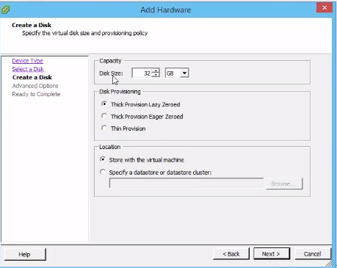

It goes to “Create a disk” page, then set the disk size from GB to TB size.

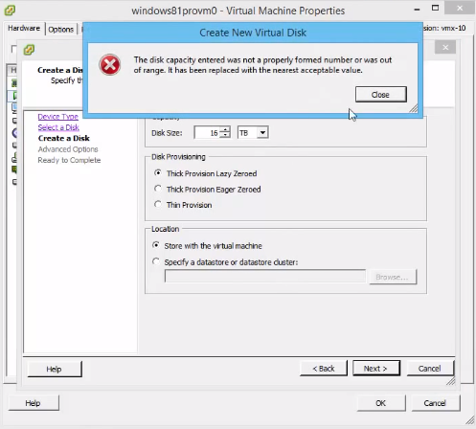

Change the disk size then it shows the restriction. Then, click on Close button and proceed by clicking on the Next button.

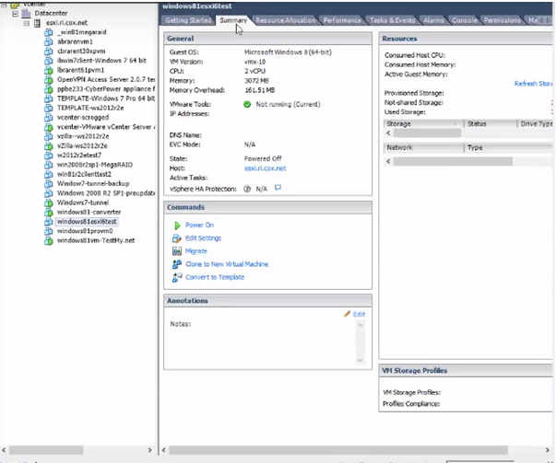

Check all the hardware memory space, Number of CPU, video card and hard disk size. Close the VMware client page.

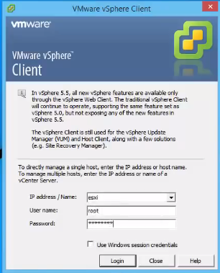

Open vSphere client for EXSi and enter the IP address, username and password.

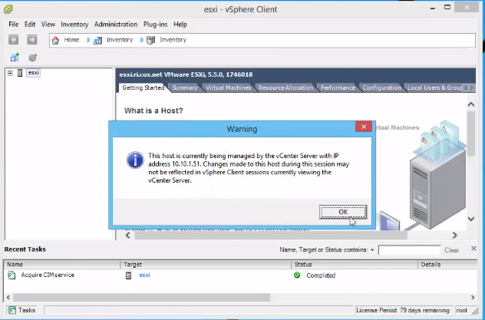

The esxi VMware client is opened. It shows the warning for the server and the client host configuration. Next, click on the Ok button.

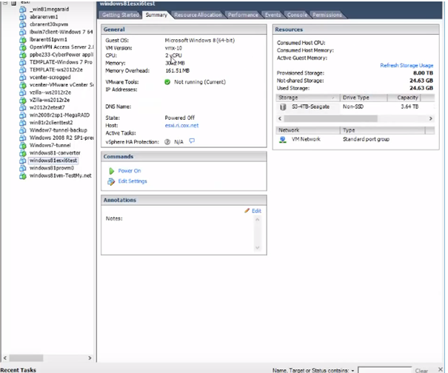

Check whether all the hardware types and the configuration summary exists, only then click on window esxitest. Next, choose the Edit settings.

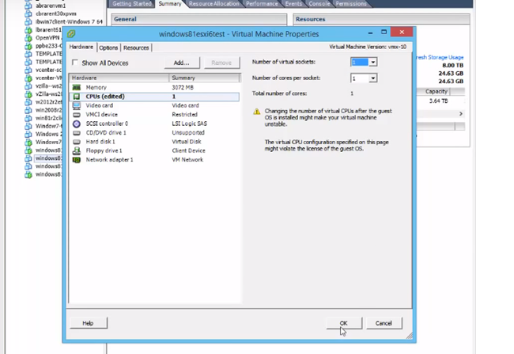

Check the number of CPUs and check all the hardware type configurations.

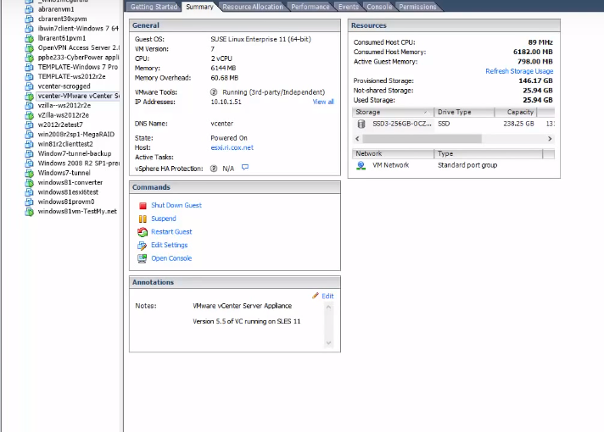

The hardware can add the esxi and configure it on esxi.

# Task 4: Configure the Management Network: DNS and Routing information for an ESXi Host

The first step is to install the VMware web client for DNS and Routing host.

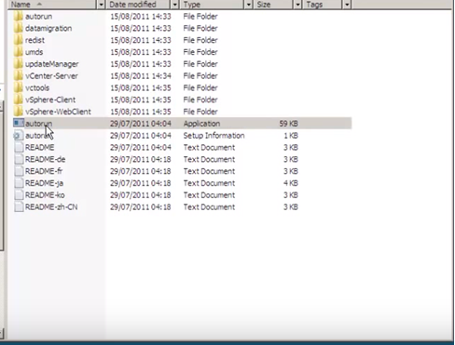

Download the VMware installer and run the application.

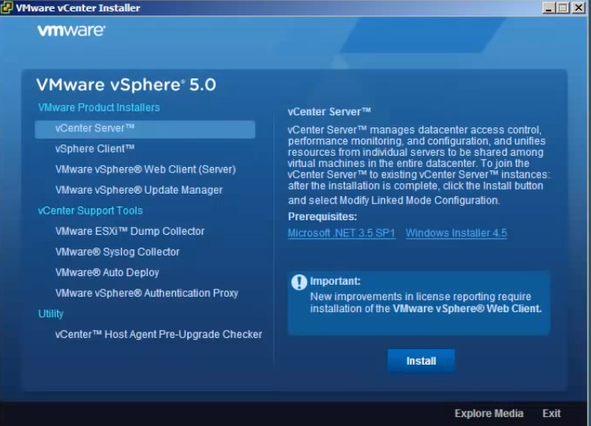

Choose the VMware vSphere web client (server) and click on the Install button for installing the web client.

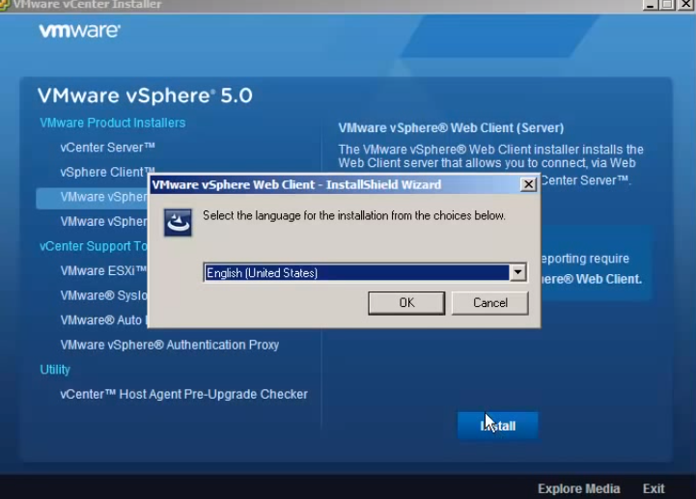

It starts the installation and choose the language, then click on the Ok button.

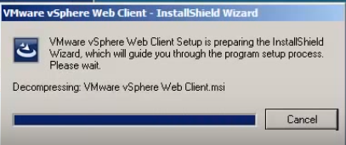

The package decompression takes place and it goes to the next page.

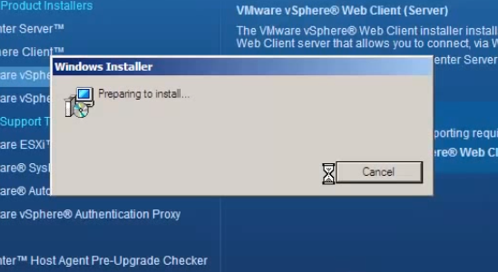

It prepares for the installation and it connects to the web client.

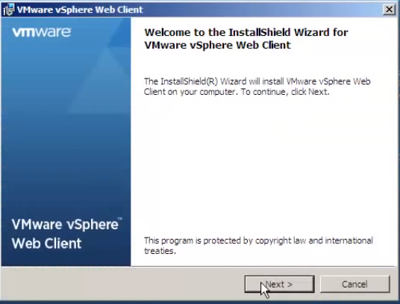

The web client install page opens and click on the Next button.

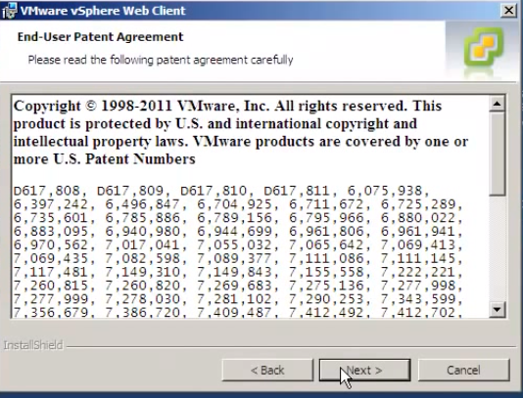

Accept the agreement and click on the Next button.

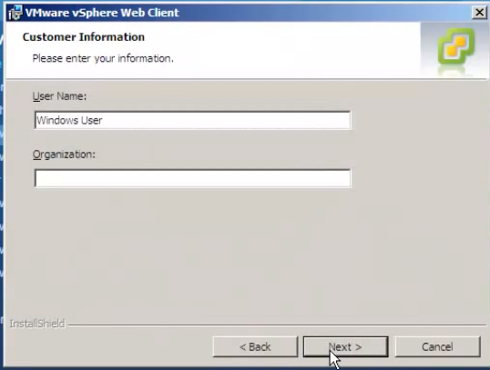

Enter the username and organization, and then click on the Next button.

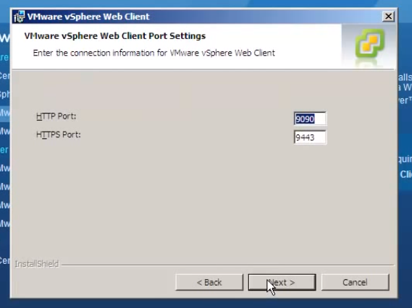

Enter the http port and https port and click on the Next button.

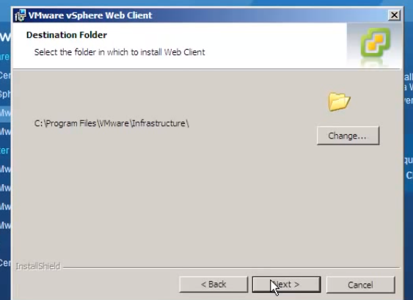

Select the folder for installation and proceed by clicking on the Next button.

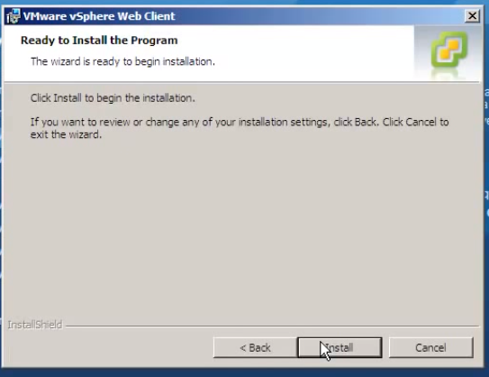

Click on the Install button for installation.

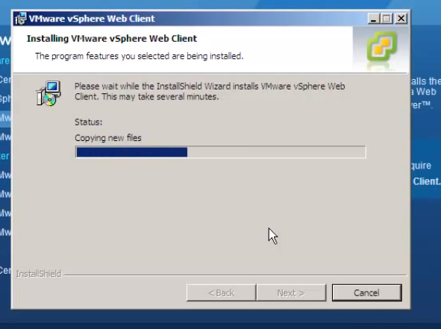

The web client installs the folder and copies all the files.

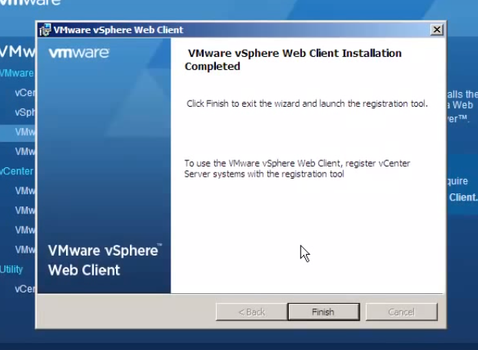

Click on the finish button and connect the web client.

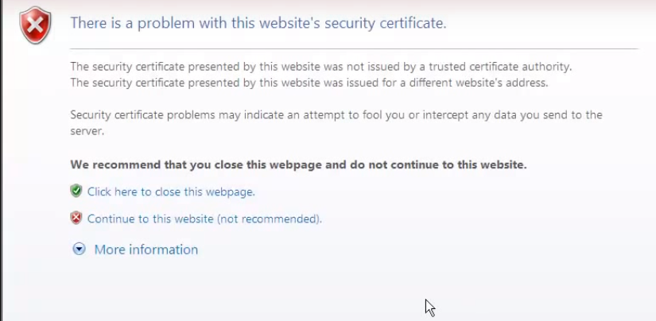

Paste the IP address in the URL, then it displays the security certificate.

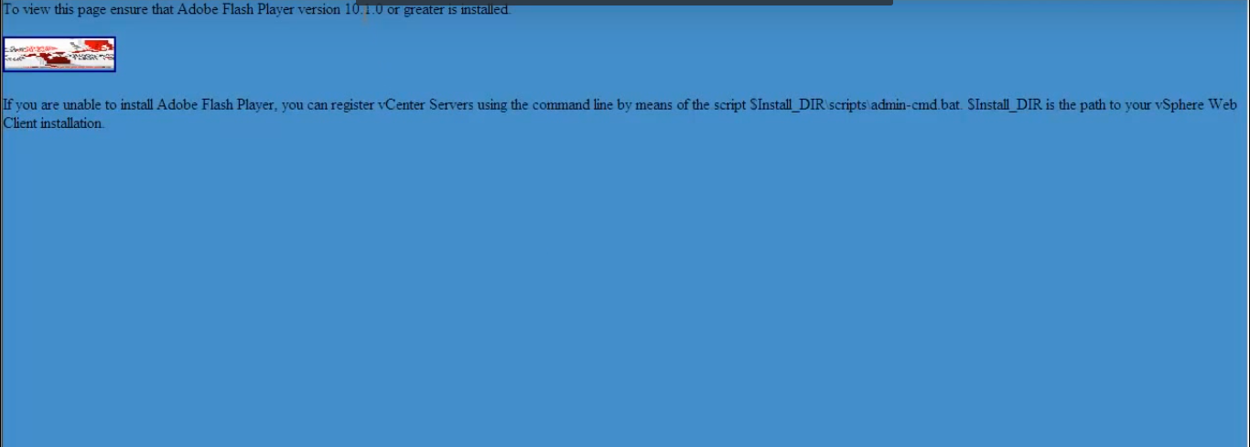

It shows the Adobe flash player installation. Click on Adobe flash, then install the adobe.

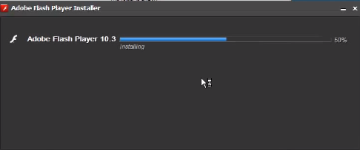

The adobe flash player installs and finishes the installation.

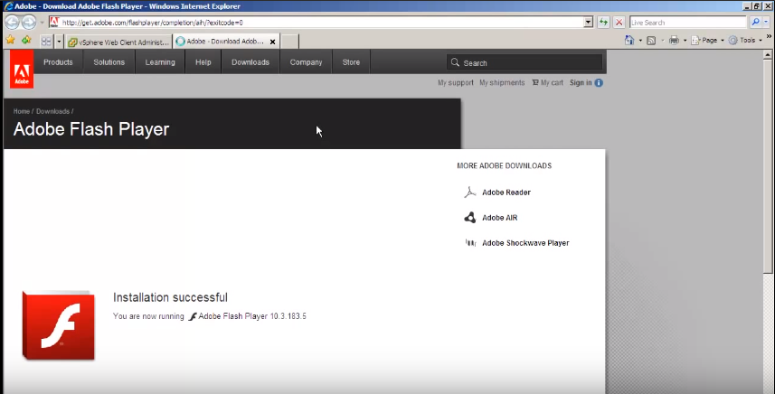

The adobe flash player is successfully installed.

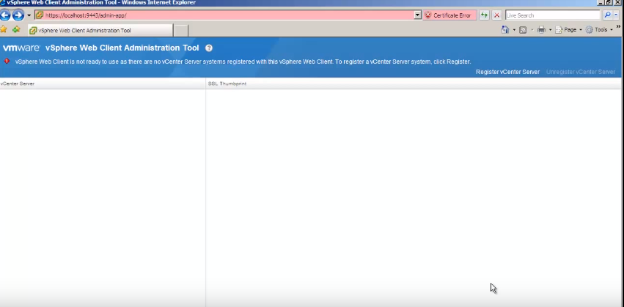

The web client connects the host and clicks on Register vCenter Server.

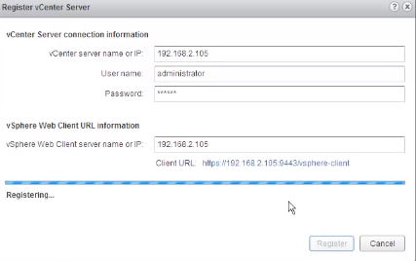

Enter the server IP address, user name and password and click on the Register button.

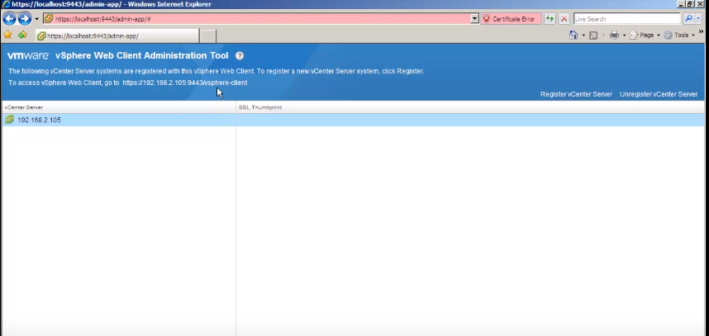

It is connected with the host and displays the web client administration tools.

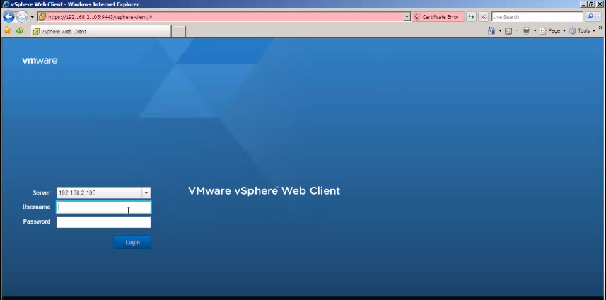

Again, paste the IP address in the URL, then it opens the VMware vSphere web client portal.

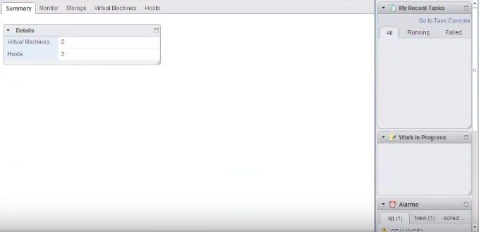

It displays the number of virtual machine and the hosts are connected to the web client. The next process is to connect the DNS and Routing host. Open the VMware web client.

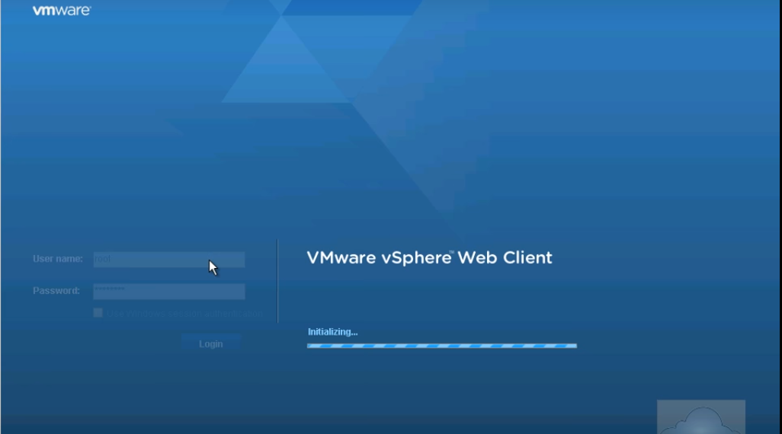

Open the VMware vSphere web client by using the username and password.

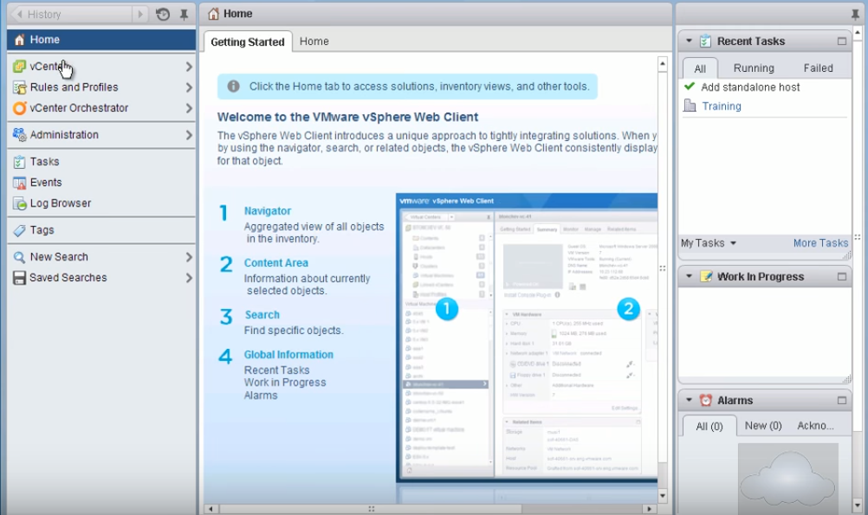

Go to the home page and click on vCenter.

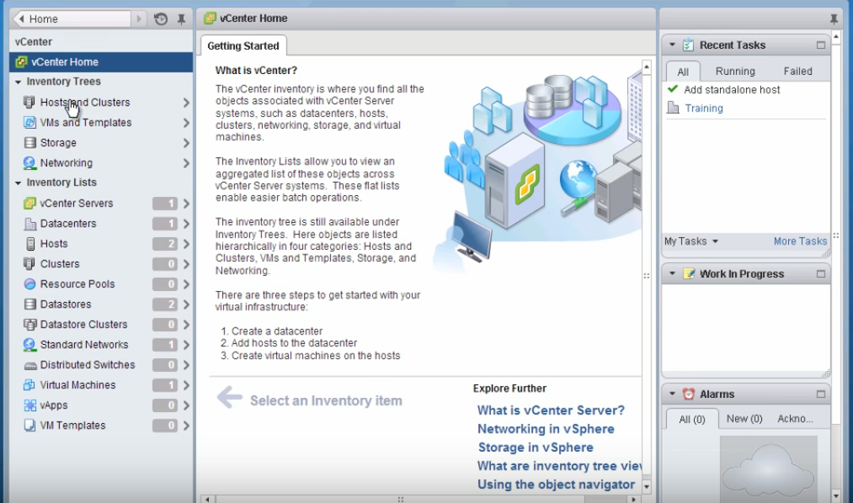

It displays the hosts and cluster, then click on that option.

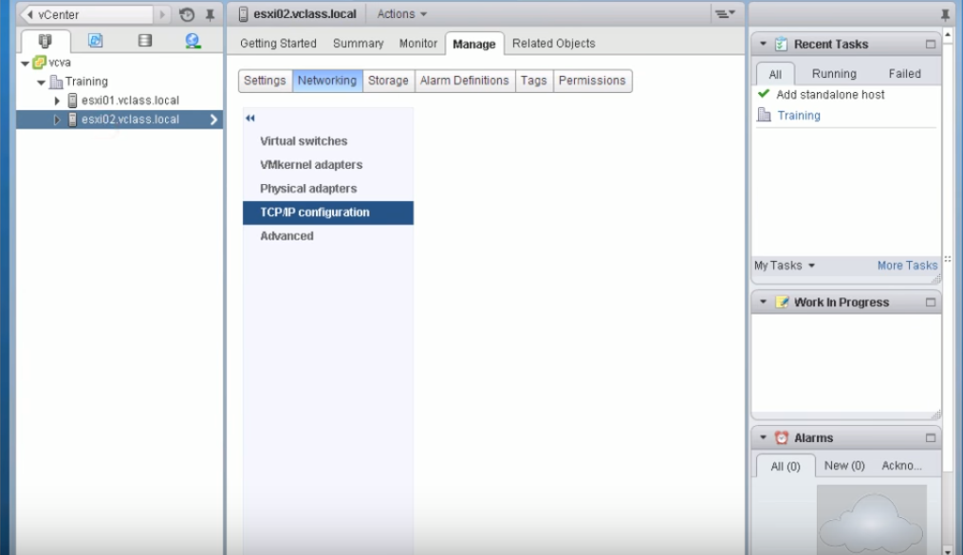

It displays the TCP/IP configuration for DNS and routing host.

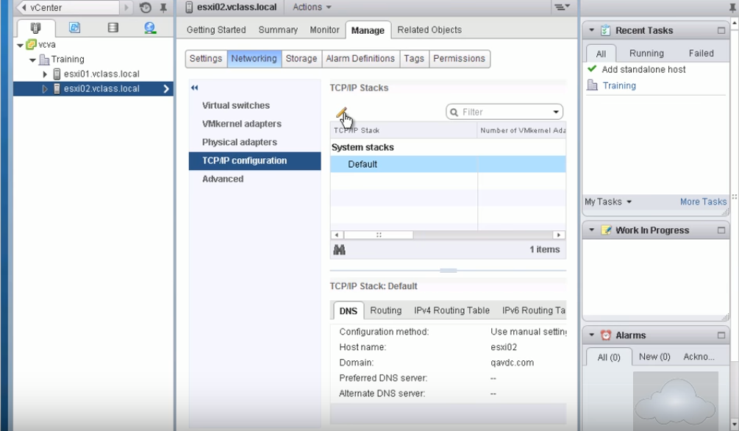

Click the TCP/IP stacks and it directs you to go to the DNS and routing configuration page.

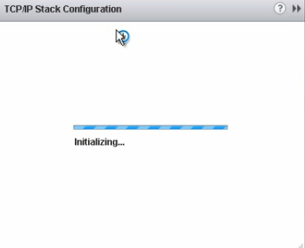

It installs the TCP/IP configuration.

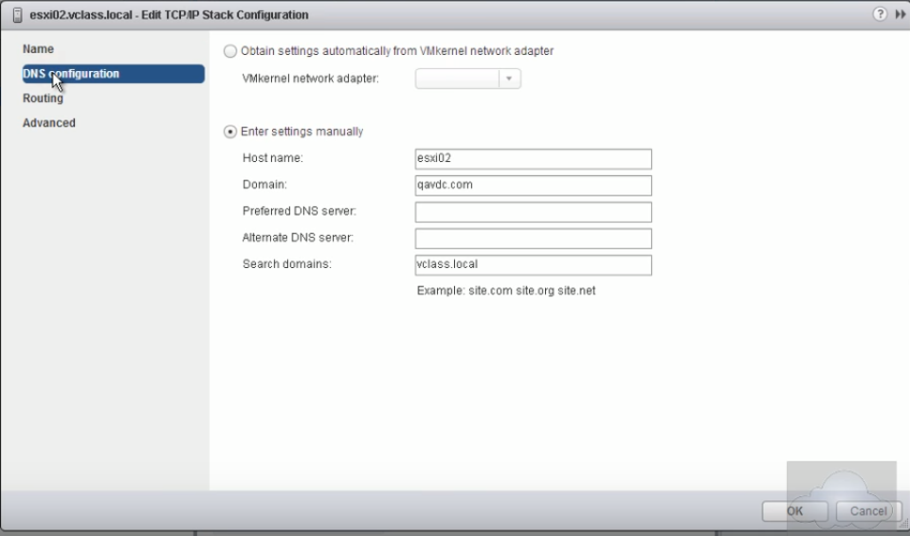

Open the DNS and routing configuration page and click on the DNS configuration. Then, enter all the host required fields.

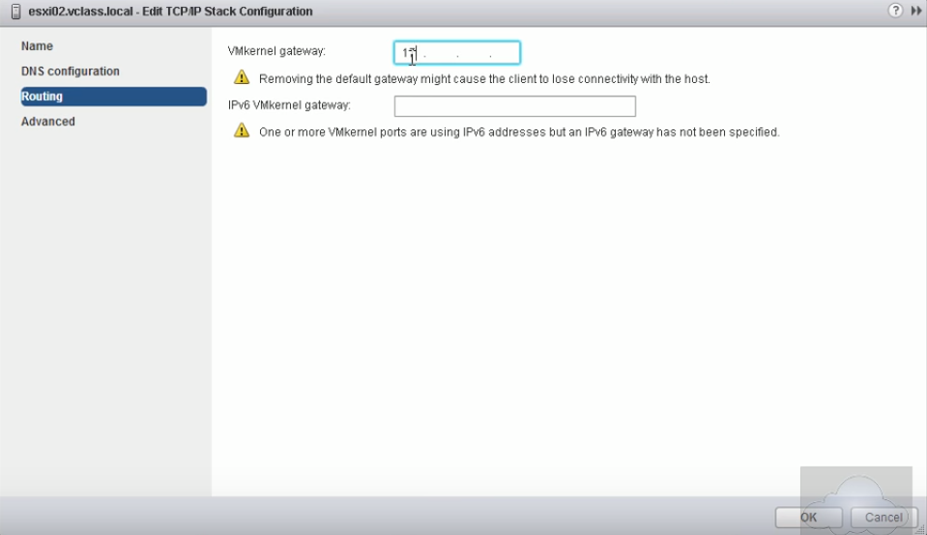

Next, click the Routing option and enter the kernel gateway address. Then, click on the Ok button.

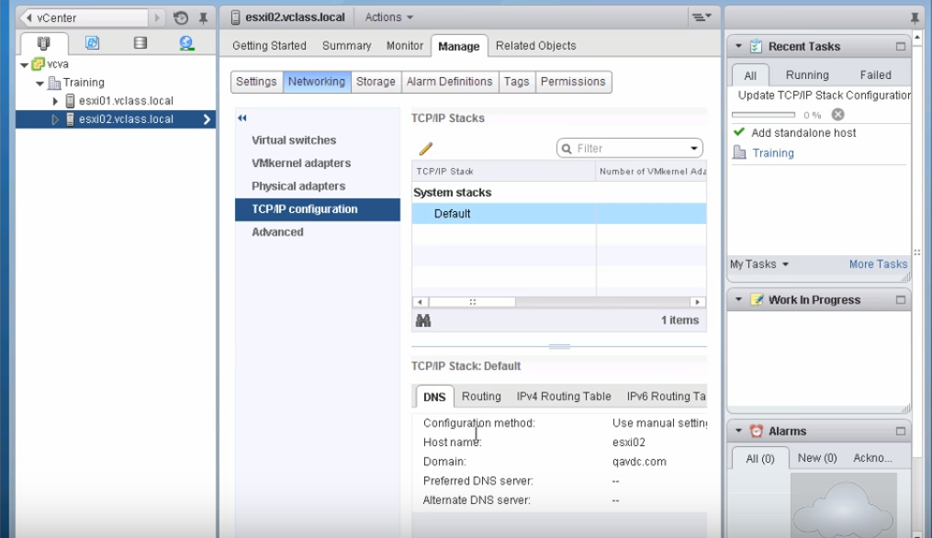

Finally, the DNS and Routing connects the ESXi host.

# Task 5: Deploy and Configure a Virtual Machine

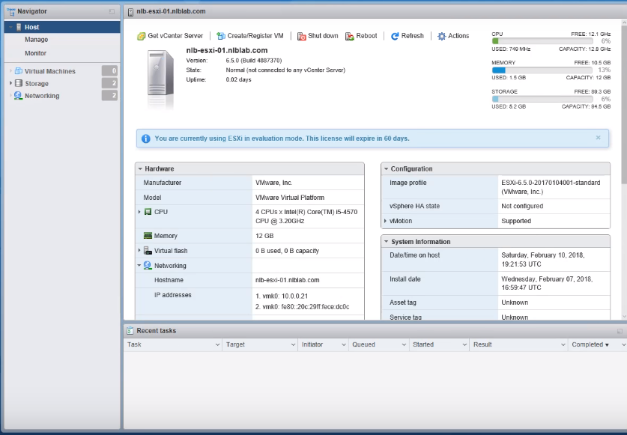

Open the VMware ESXi and it displays the host, virtual machines and networking.

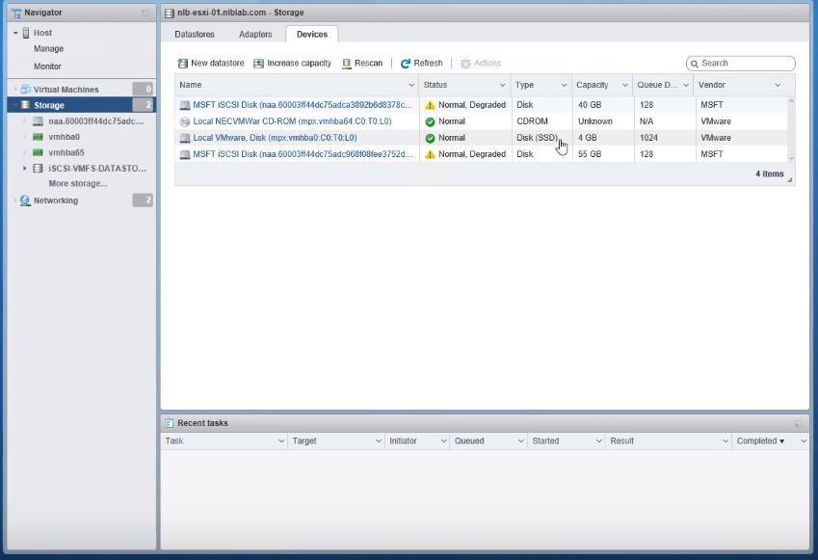

Click on the Storage option and it displays the available devices. Then, click on the local VMware.

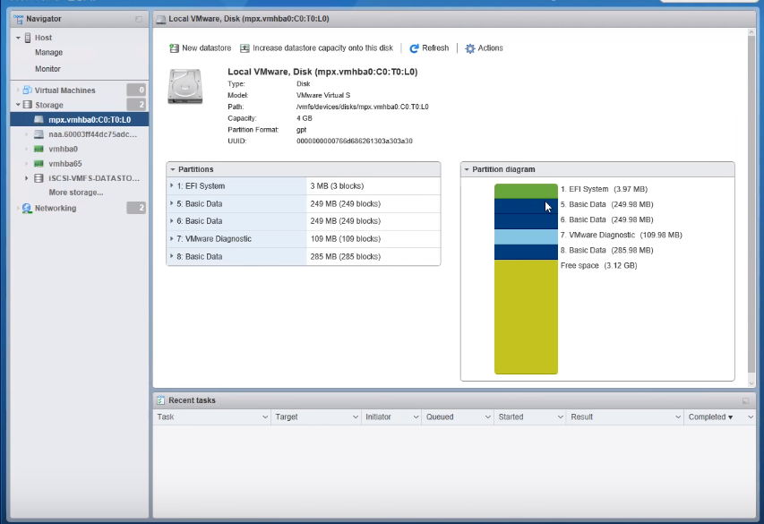

It displays all the space for the local VMware disk.

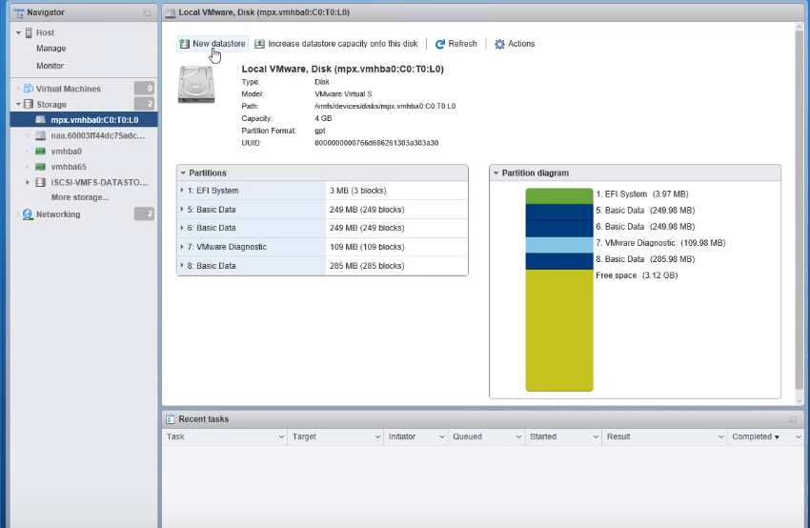

Click on the new data store and add the new data store.

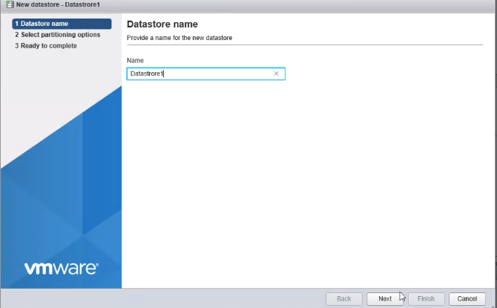

Give the data store name and click on the Next button.

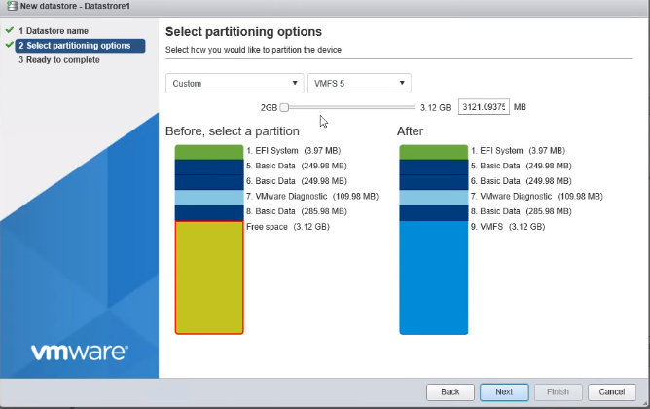

Next, is to select the portioning options for the disk space and then check the space. Further, click on the Cancel button.

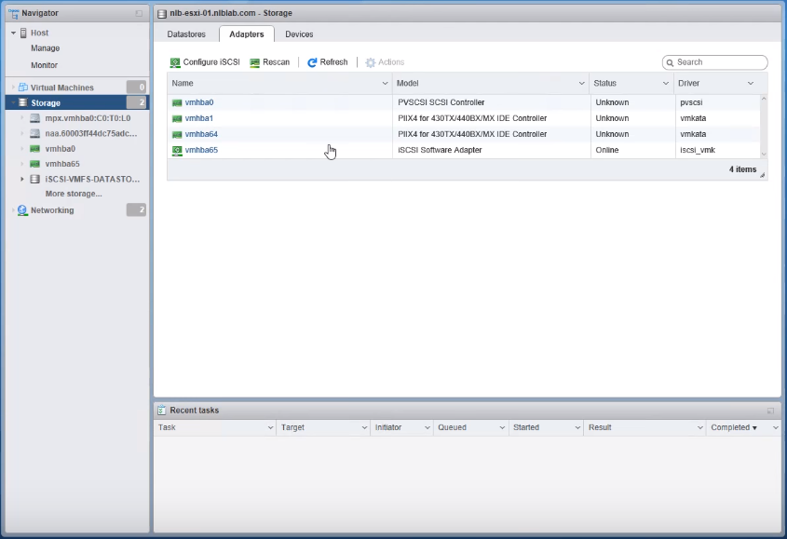

Go to the VMware ESXi and check the Adapters.

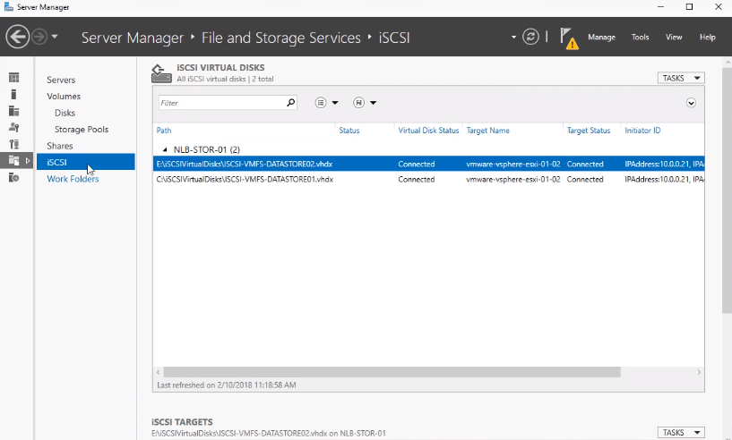

Go to the server, to manage the file and storage service.

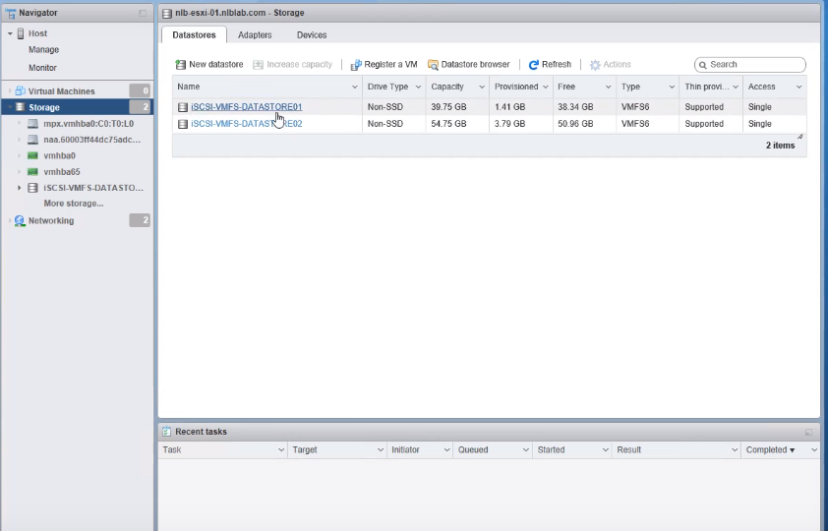

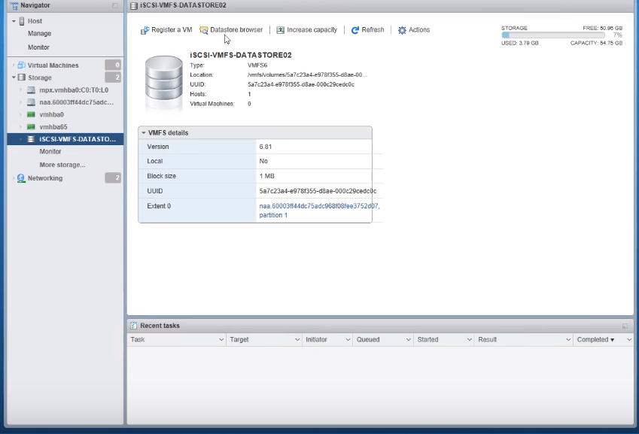

Click on the iSCSI data store on VMware ESXi, and click on the data store browser.

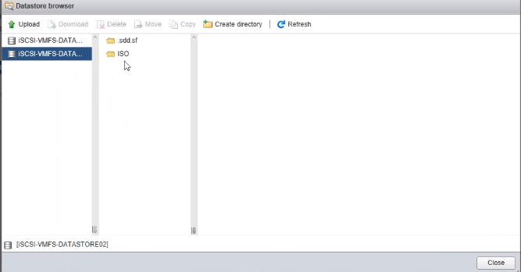

Click on ISO for importing the ISO file to VMware esxi.

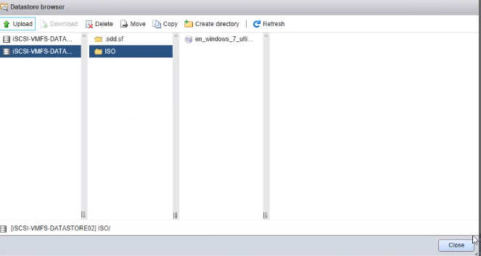

The window 7 ISO file imports the iSCSI data store.

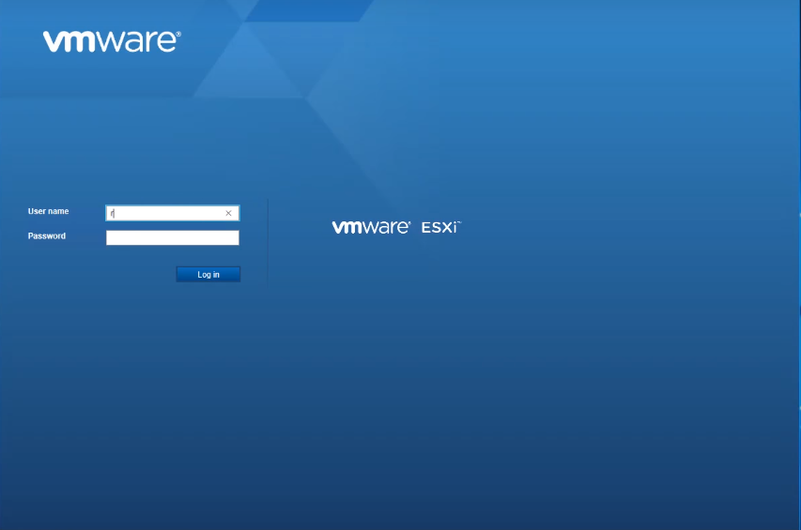

Open the VMware ESXi by using the username and password.

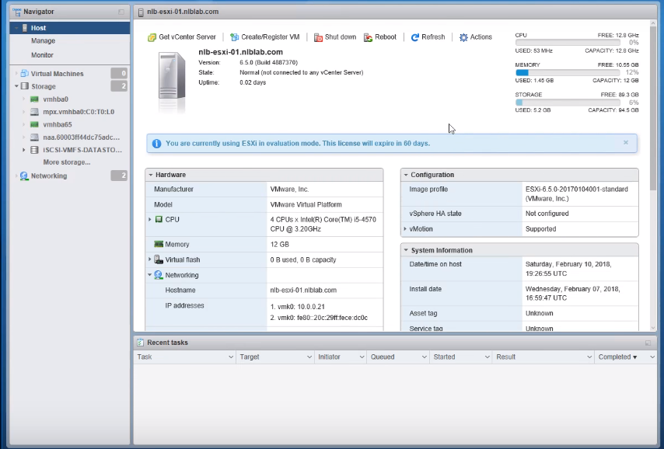

It opens and checks the number of virtual machine, storage space, etc.

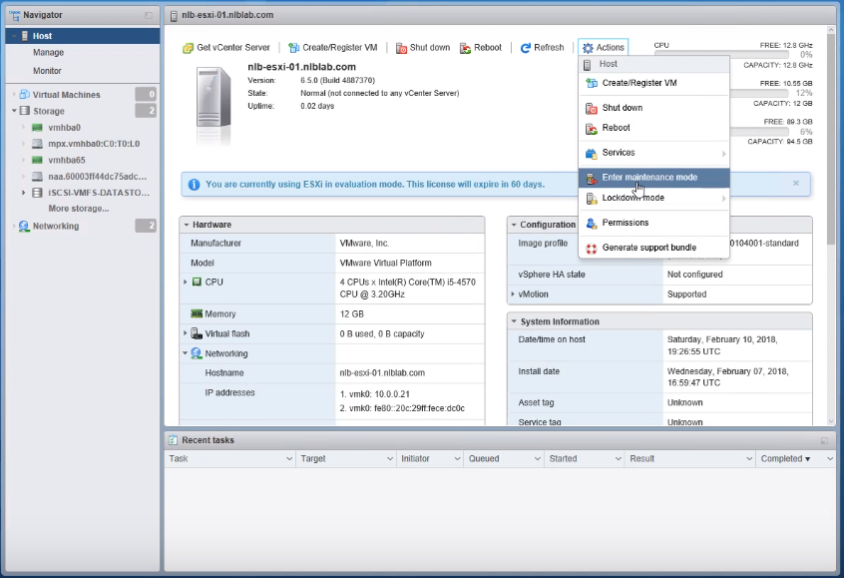

Click on the create register VM for creating a new virtual machine.

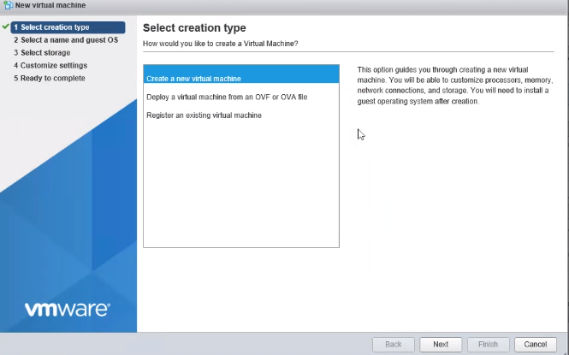

The first step is to select creation type as create a new virtual machine, and then click on the Next button.

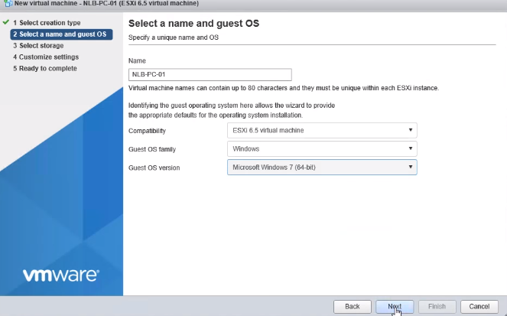

Enter the name and chose the guest OS for Windows, then click on the Next button.

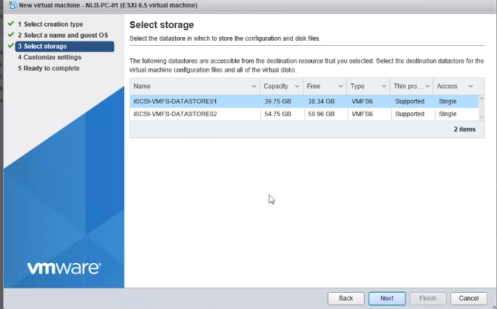

Select the storage for virtual machine and click on the Next button.

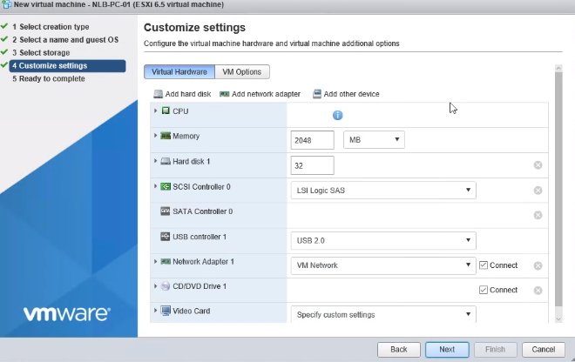

Next, for customize settings have the virtual machine hardware and additional options. Then, proceed by clicking on the Next button.

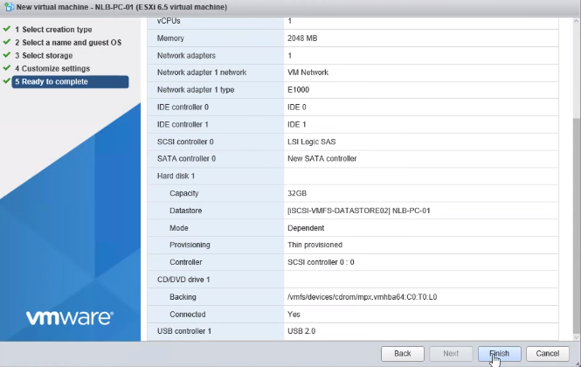

Click on the Finish button and get ready to complete.

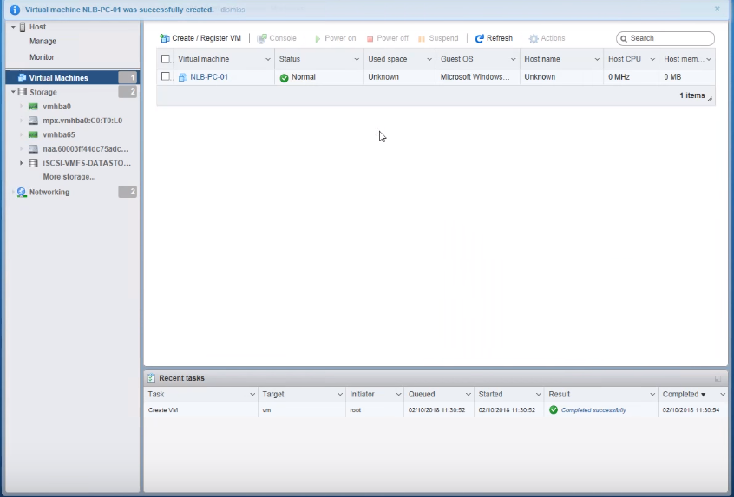

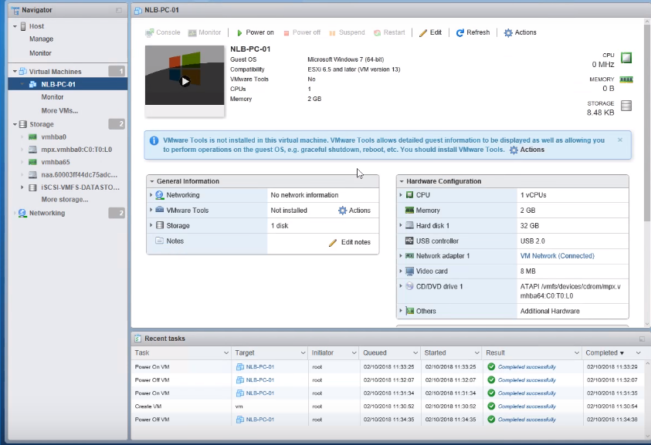

Window 7 installs on the VMware, and click on the Windows 7 vmware.

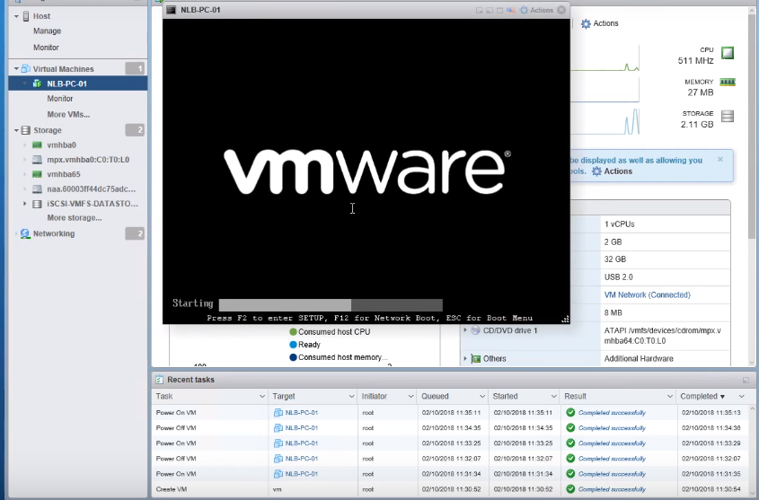

The VMware starts to open Windows 7.

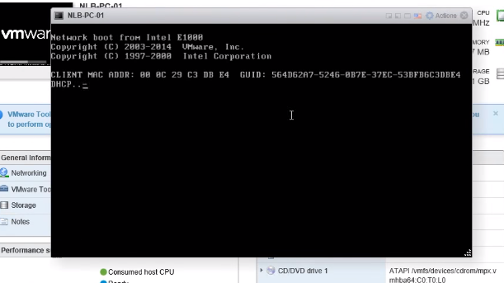

It connects the DHCP and is closed automatically.

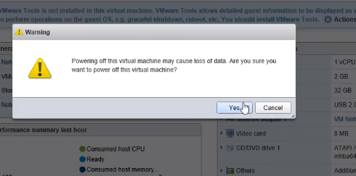

Power on the virtual machine and it shows the warning. Then, click on the Yes button.

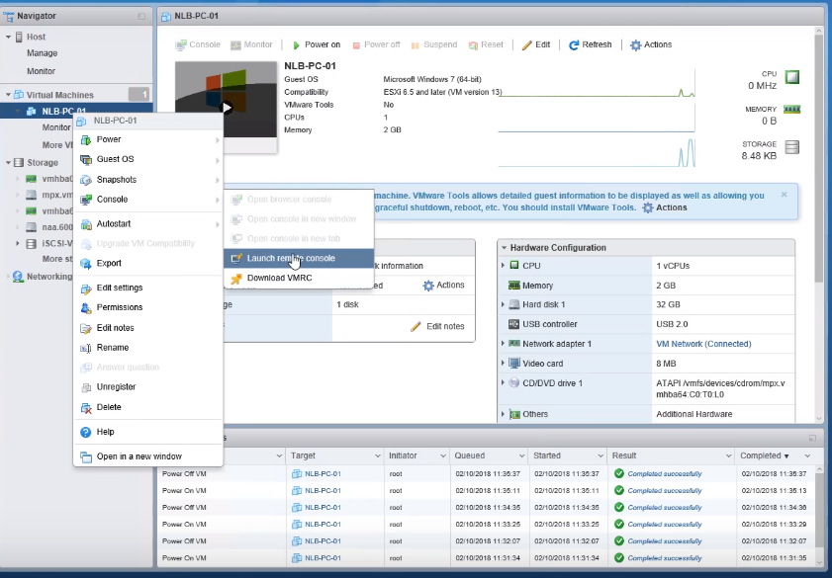

Go to NLB PC and launch the remote console.

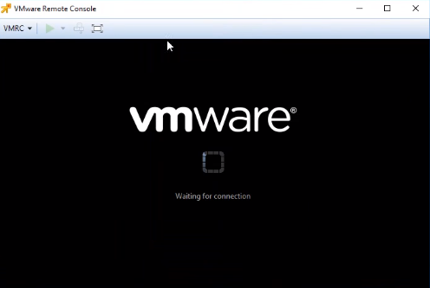

The above figure shows waiting for the connection of VMware remote console.

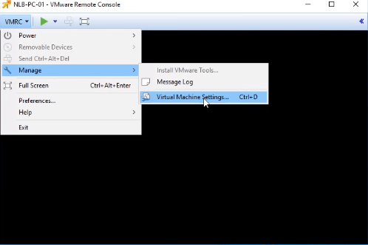

Install the virtual machine tools for windows. So, click on the VMRC option and go to the Manage option and select Virtual machine settings.

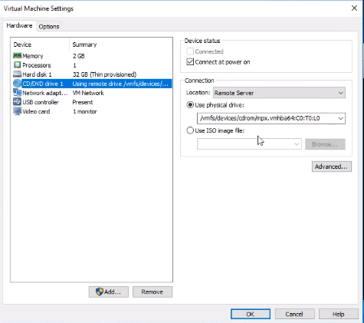

Click on the CD/DVD drive and it display the ISO image file option. Import the ISO file.

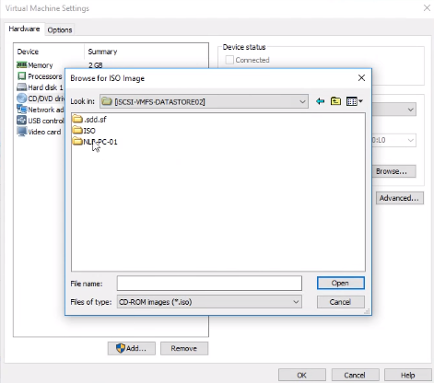

The ISO image file imports on the virtual machine, and click on the Ok button.

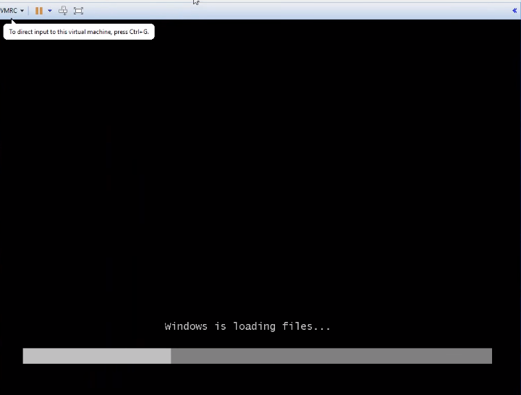

In the above figure, for opening Windows, the files are loading.

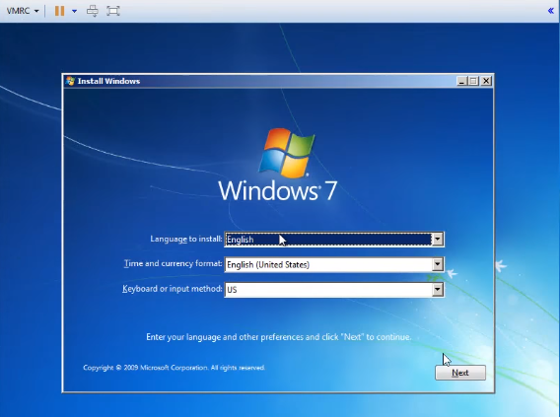

The window 7 install page opens and choose the language, then click on the Next button.

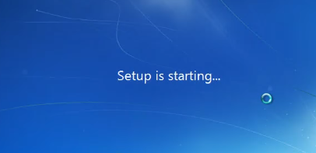

The windows 7 setup starts.

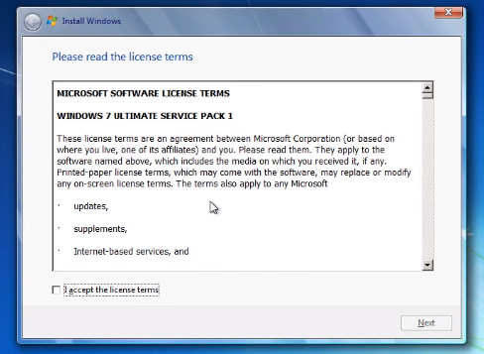

Accept the license for windows 7 and click on the Next button.

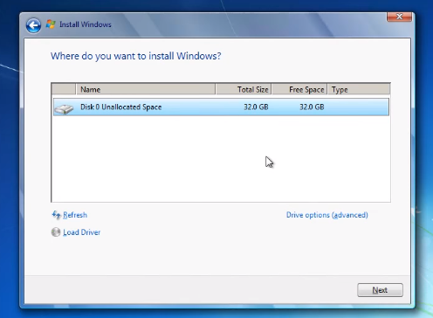

It allocates the disk space, then click on the Next button.

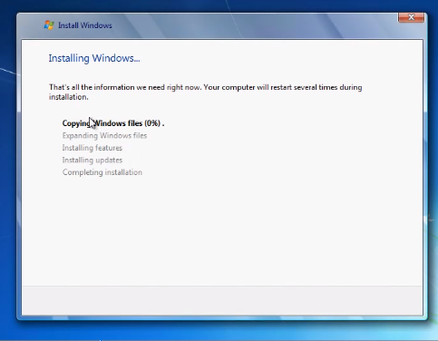

The files are copied for installation.

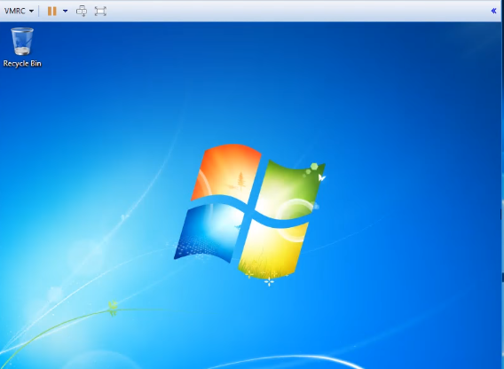

The windows 7 opens with virtual machine.

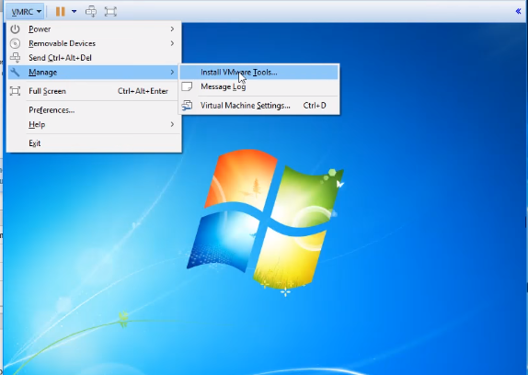

Go to Manage option and select Install VMware tools settings.

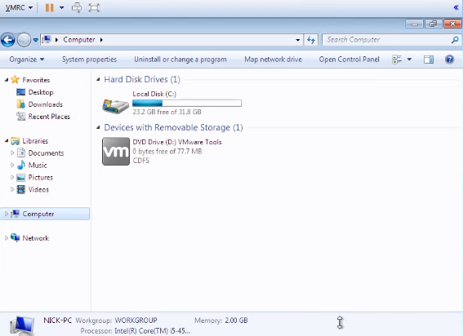

Open the computer on window 7, then go to the VMware tools storage and click on the DVD drive.

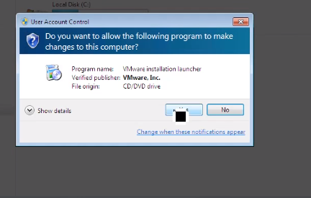

It displays the program name, then click on the Yes button.

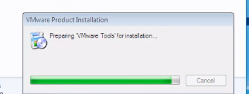

The VMware tools are preparing for the installation in the above represented figure.

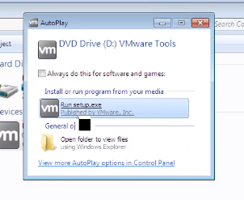

Again the setup files are displayed, then click on the Run setup.

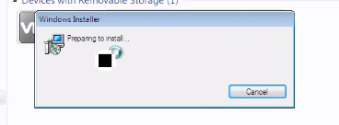

It prepares to install the VMware tools.

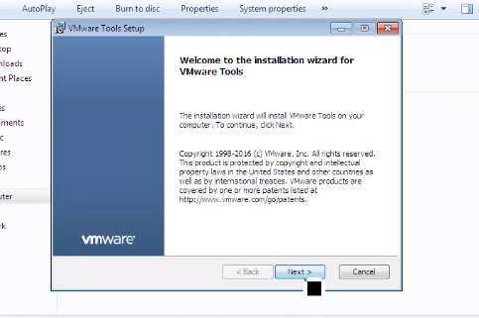

It opens the VMware setup file then, click on the Next button.

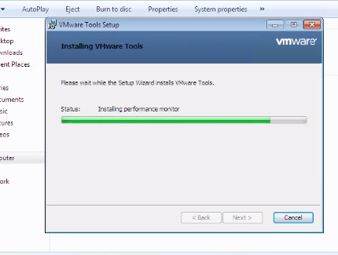

The tools are installed, so proceed by clicking on the Next button.

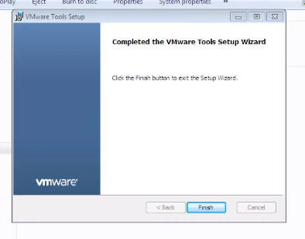

Click on the Finish button and then the installation is completed.

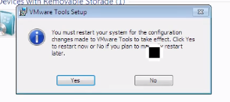

Click on the Yes button for VMware tool’s setup.



It automatically logs off after clicking on the Yes button.

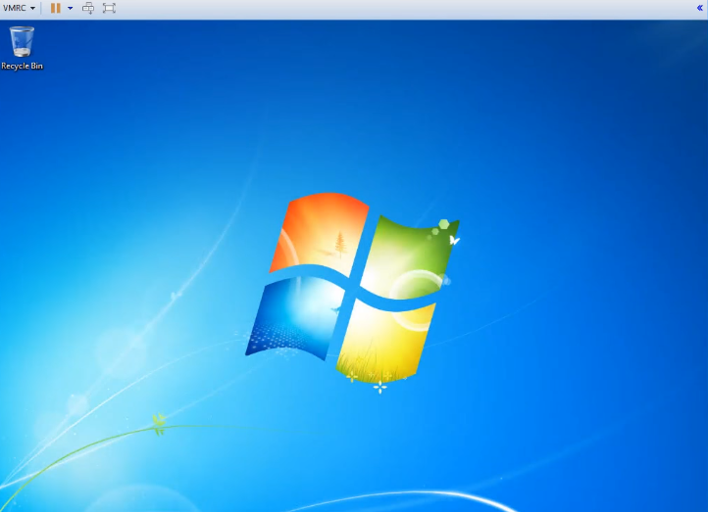

Windows is opened with VMware tools.

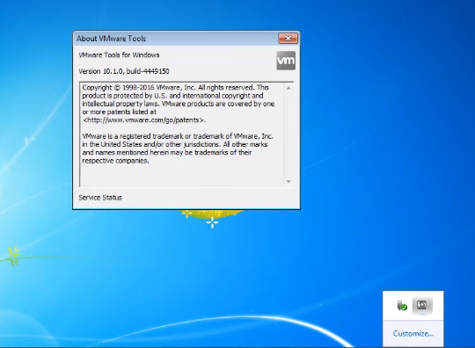

Click the VMware tools on windows 7.

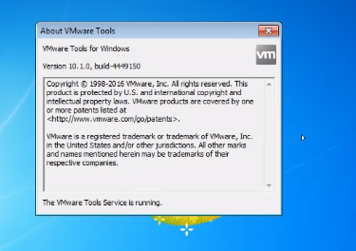

The VMware tools service runs on windows.

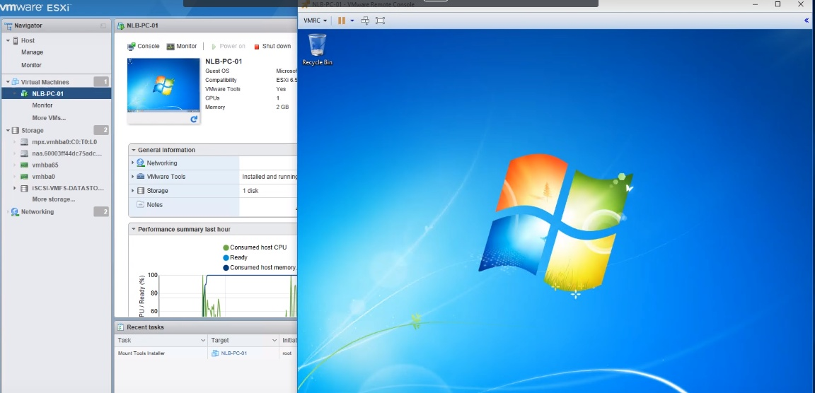

The virtual machine configures the windows.

# Task 6: Install and Deploy vCenter Server Appliance

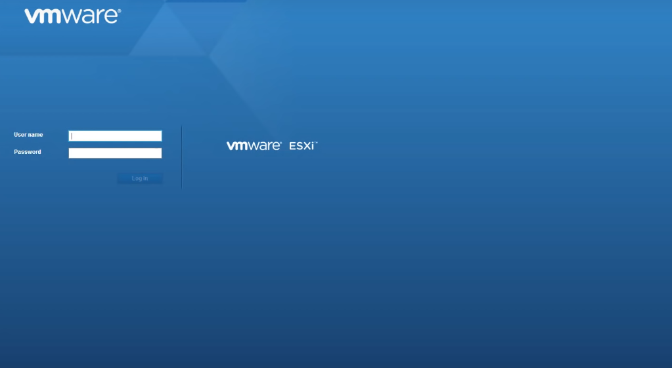

Open the VMware ESXI by using the username and password.

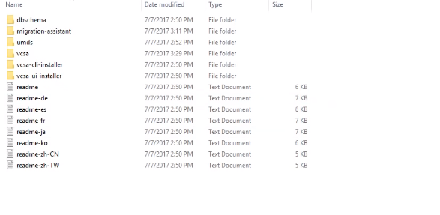

Download the vCenter server appliance installer.

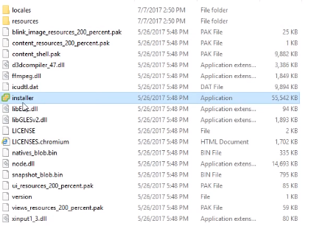

Click the installer application and the supplication will be installed.

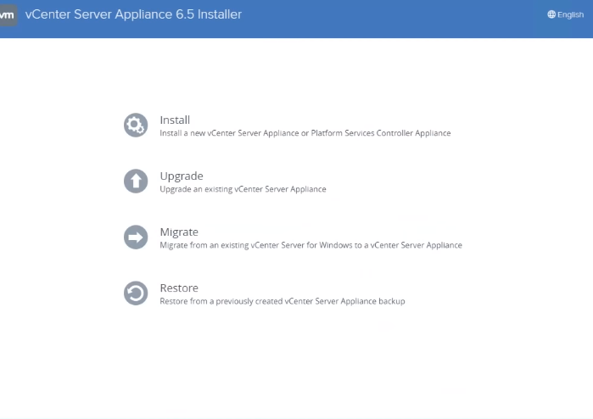

The vcenter server appliance opens and click on the Install option.

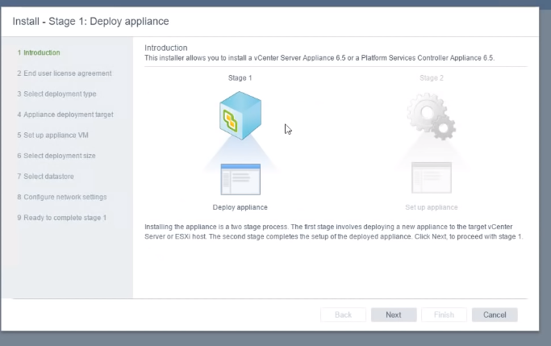

The first step is to deploy the application stage 1 and click on the Next button.

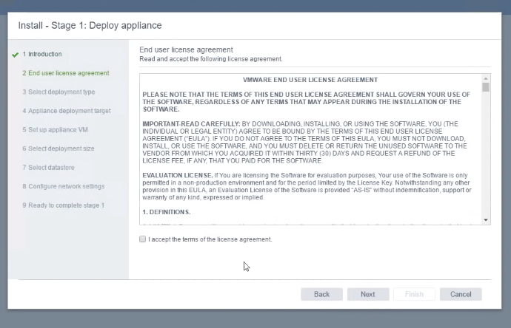

Accept the license and click on the Next button.

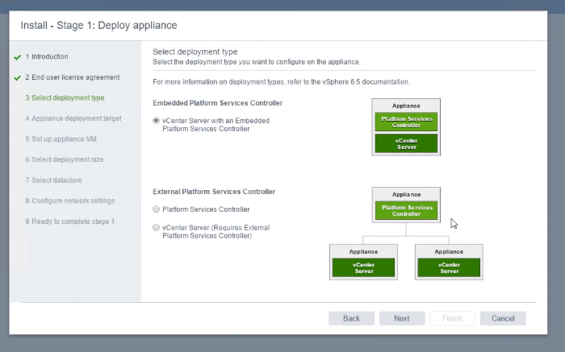

Select the deployment type and click on the Next button.

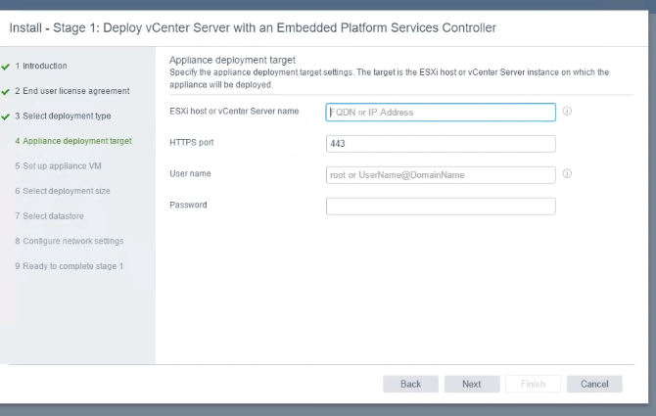

Enter the deployment target field and click on the Next button.

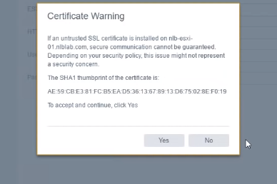

It shows the certificate warning and click on the Yes button.

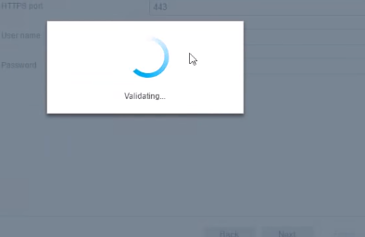

It checks the validity of the certificate.

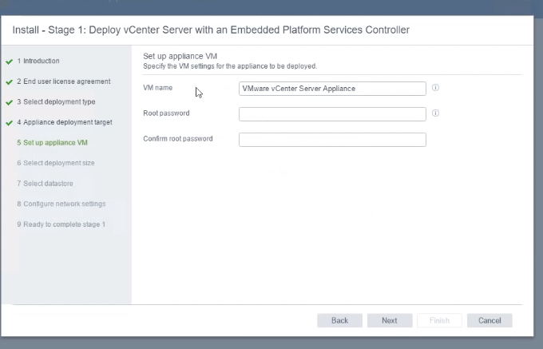

Enter the VMname, root password and click on the Next button.

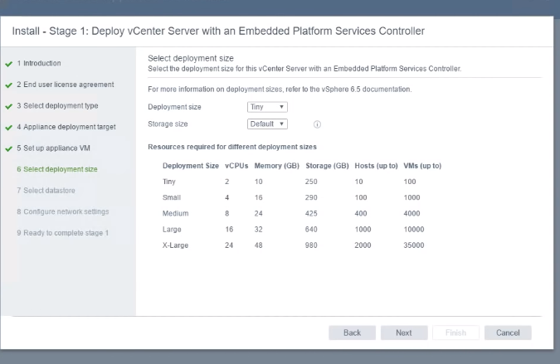

Select the deployment size an click on the Next button.

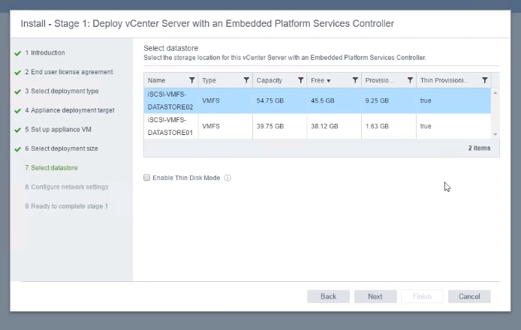

Enable the disk mode and click on the Next button.

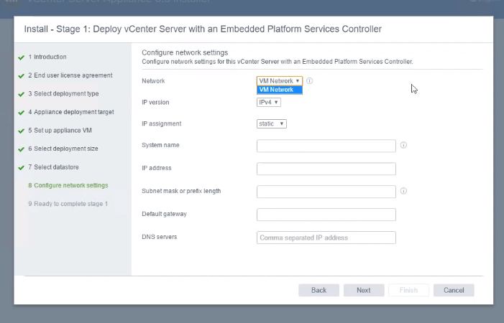

Enter the configure network address, name and click on the Next button.

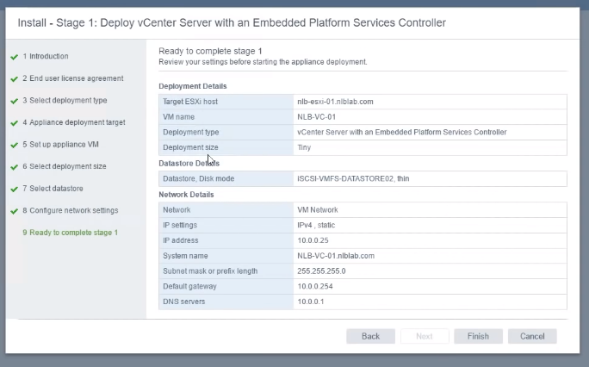

It displays the configure network settings and click on the Finish button.

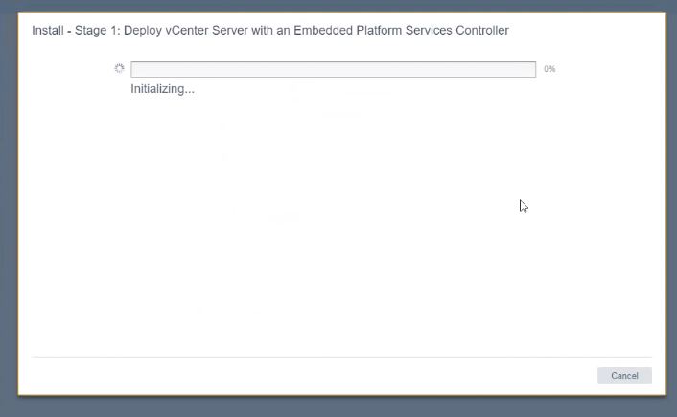

It automatically initializes and finishes the configure settings.

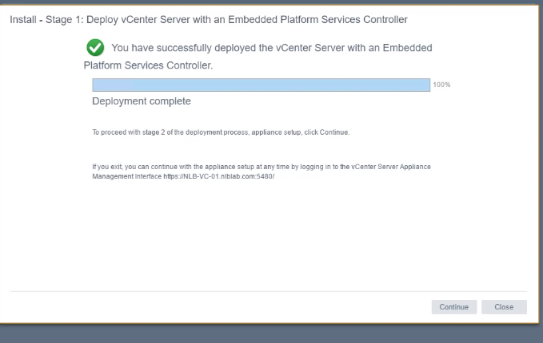

Deployment is successfully completed and click the continue button.

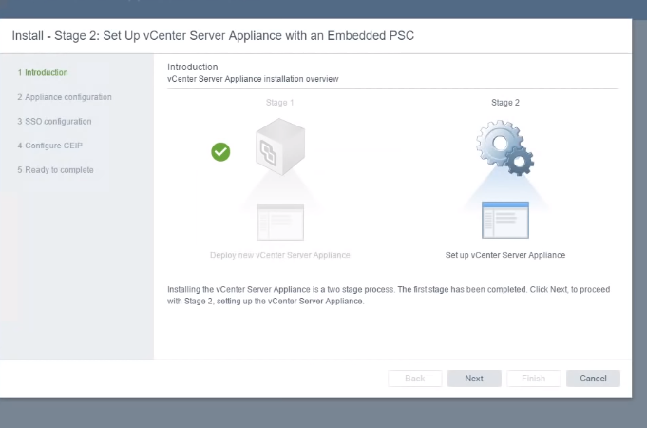

The stage 1 is completed and then go to the stage 2 and click on the Next button.

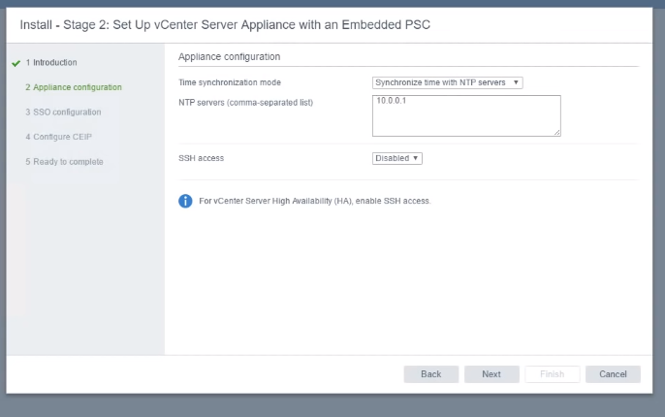

Enter the NTP server address and click on the Next button.

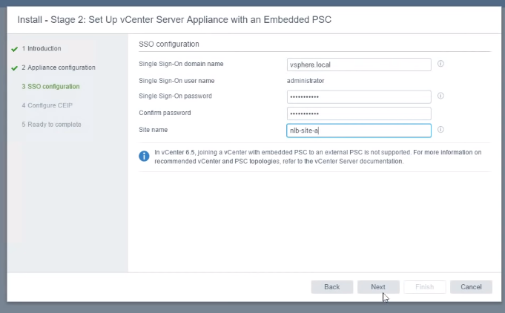

Enter the SSO username, password and site name, then click on the Next button.

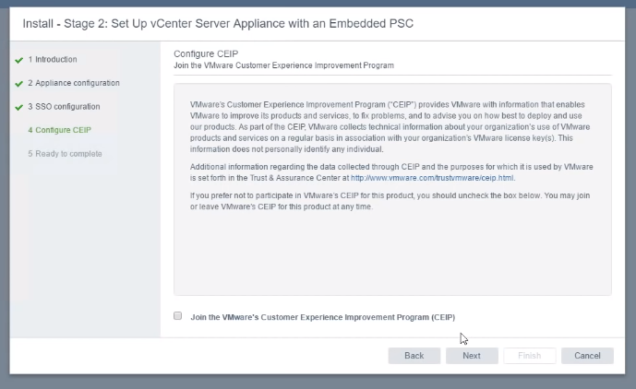

Next step is to configure the CEIP and disable the join VMware. Then, click on the Next button.

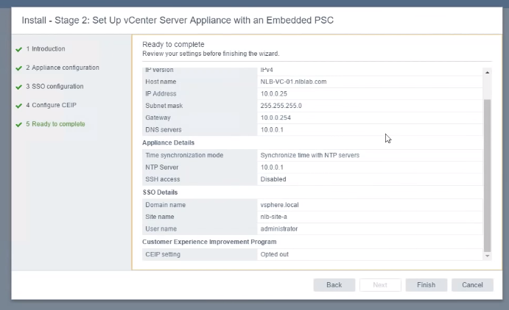

The process completes, so click on the Finish button.

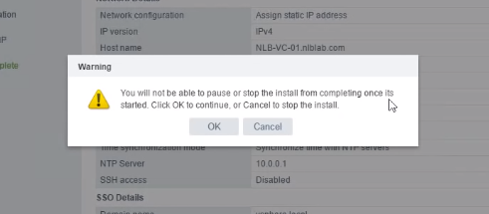

It shows warning, then read the warning and click on the Ok button.

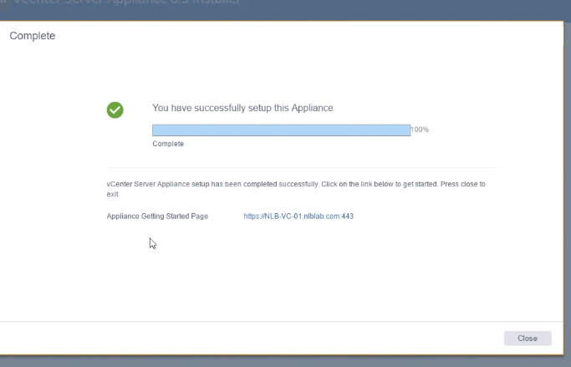

The setup file was successfully completed. 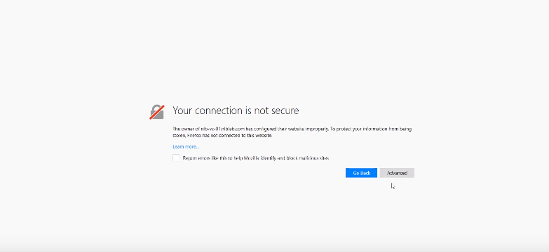

Connect the host and go to the advanced option.

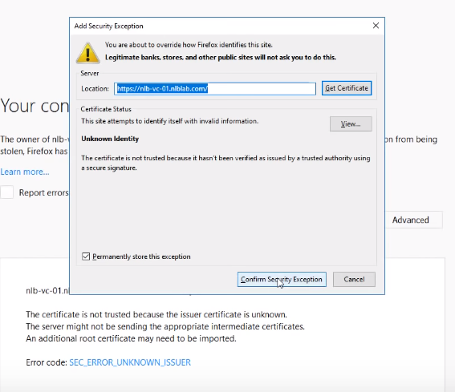

Confirm the security option and it opens the server.

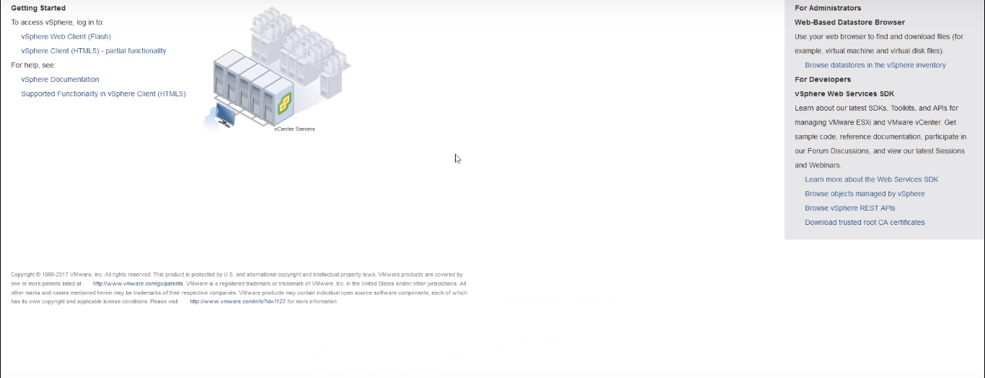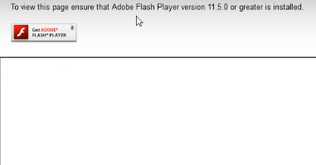

Install the Adobe flash player.

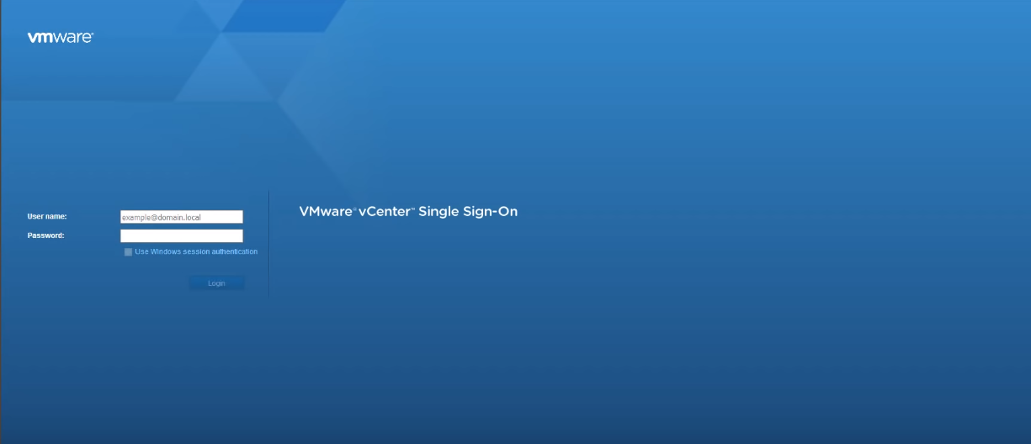

The VMware vcenter page opens after Adobe installation.

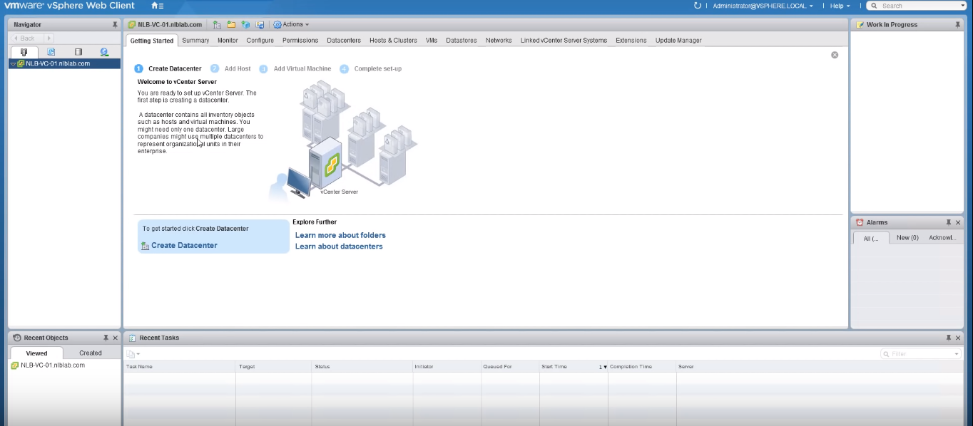

The VMware web client opens and start the application.

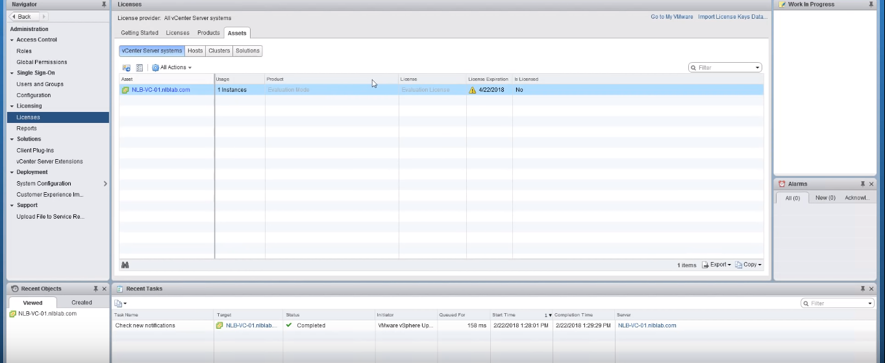

Get the license for that application.

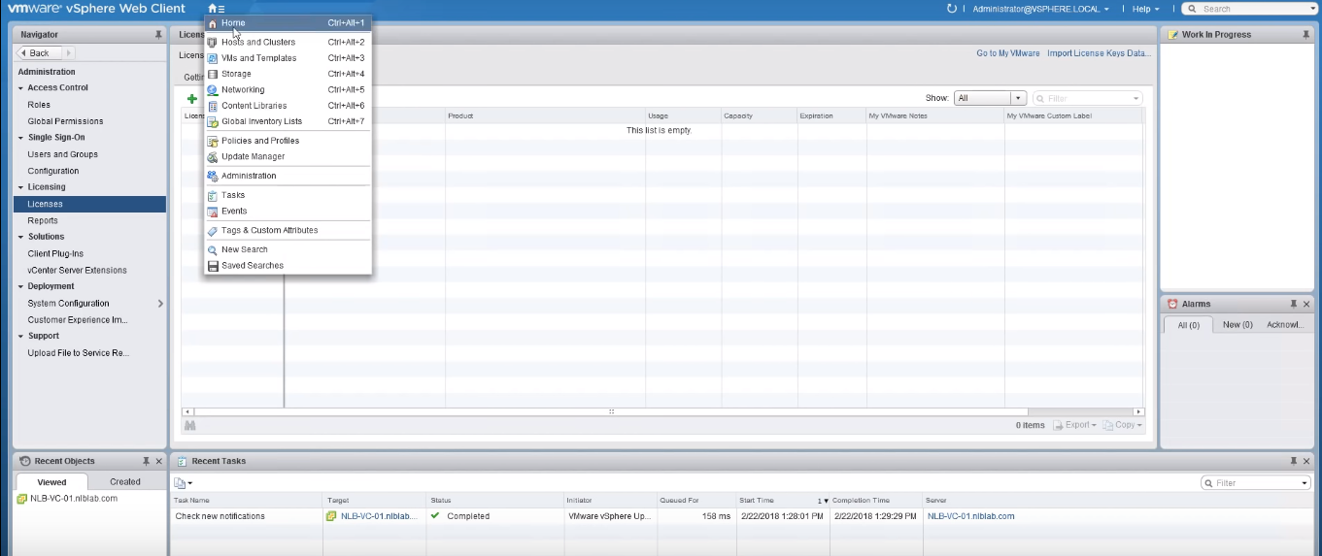

Go to the home page and configure the host.

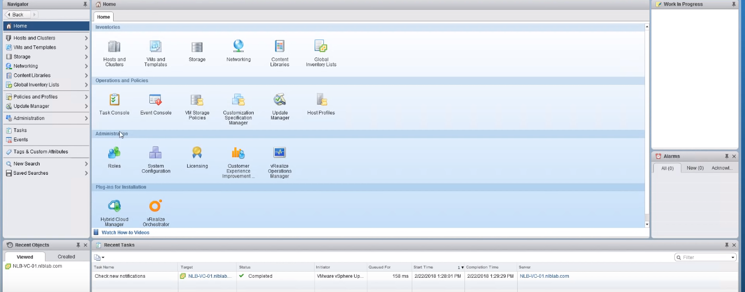

It is the home page for the web client.

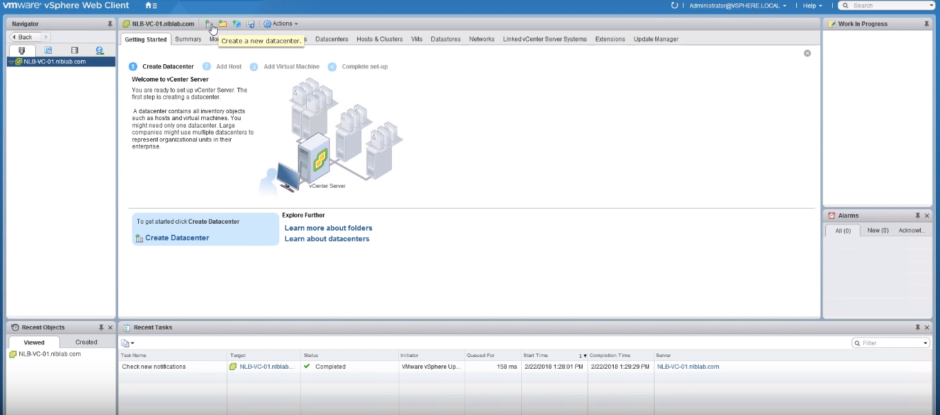

Click on Create new datacenter.

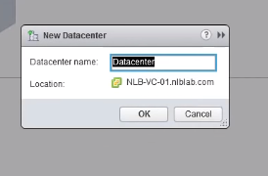

Enter the datacenter name and click on the Ok button.

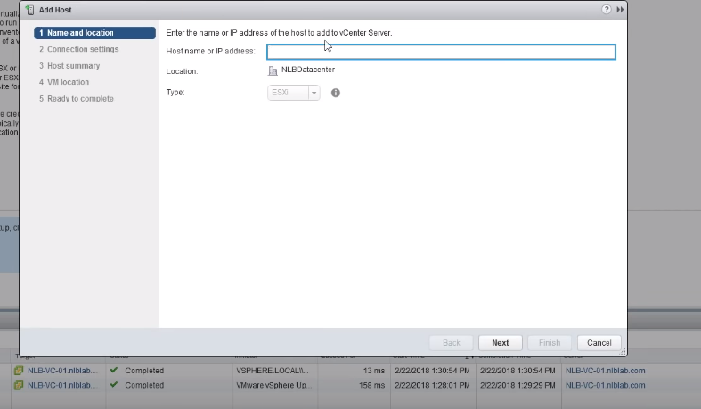

Enter the IP address for network connection and click on the Next button.

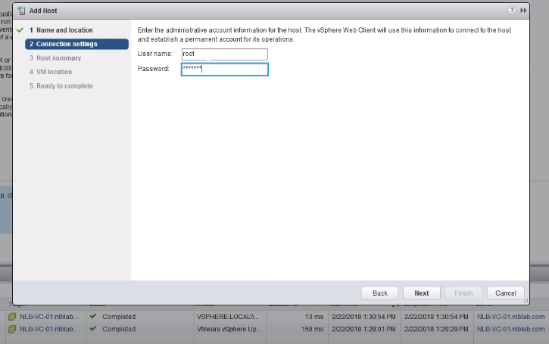

Enter the username and password, then click on the Next button.

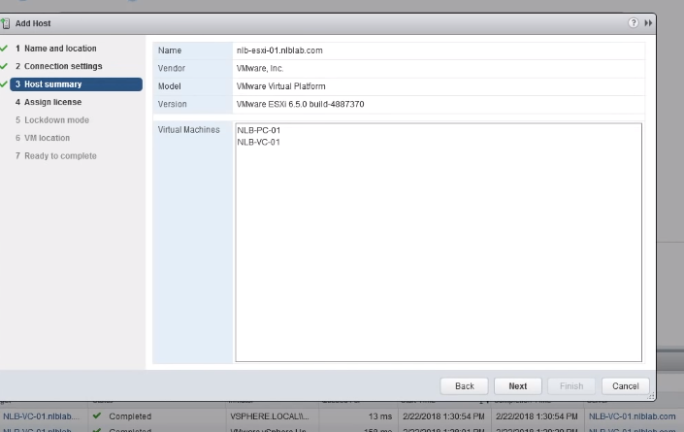

Click on the Next button for VM location.

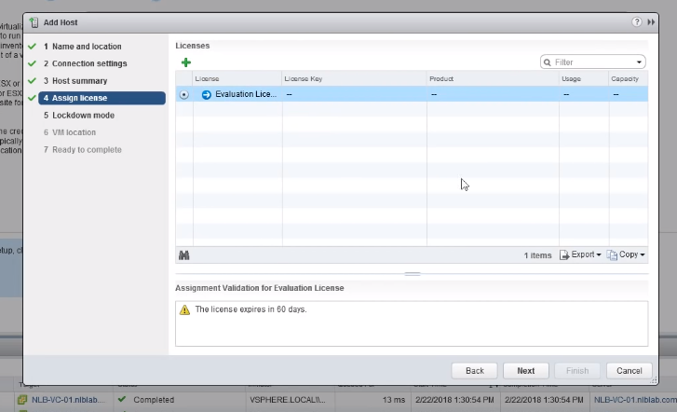

It assigns the license for the host and click on the Next button.

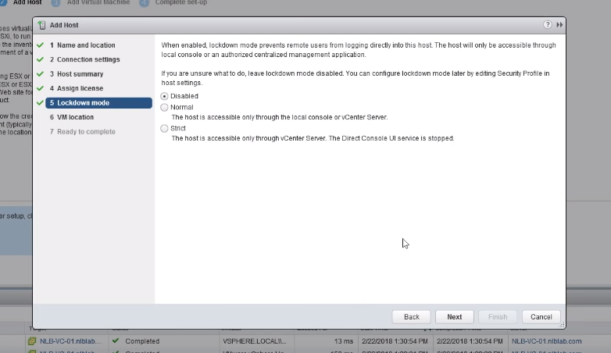

Disable the lockdown mode and click on the next button.

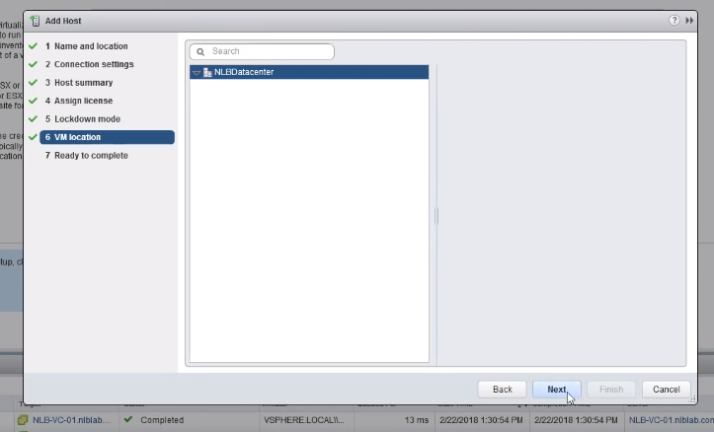

Select the location and click on the next button.

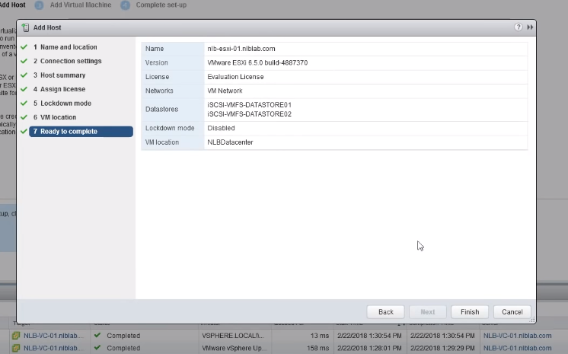

Click on the Finish button.

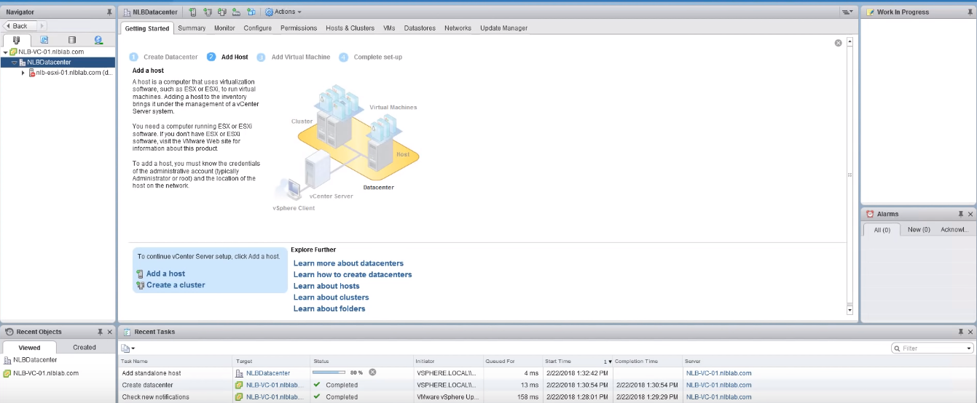

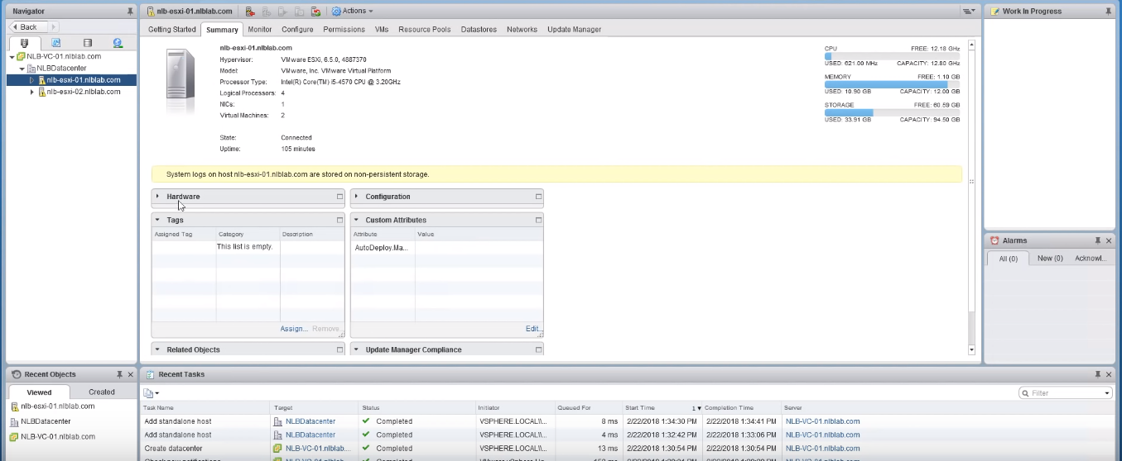

Click on the first datacenter for configuration.

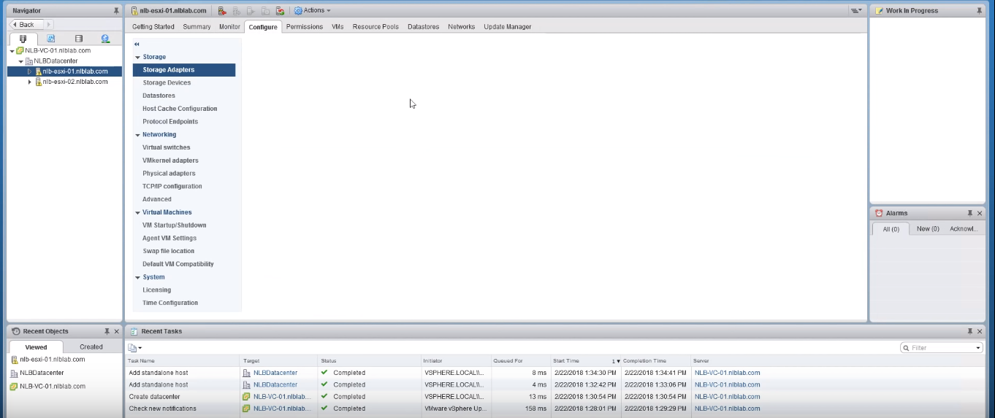

Click on Configure and set the time.

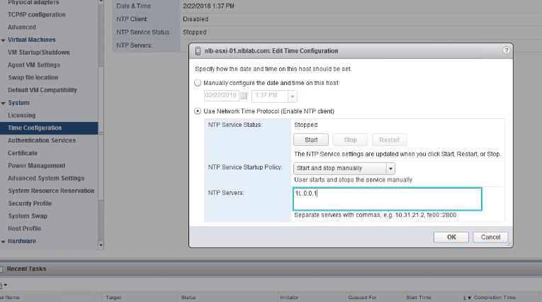

Add the server address and click on the Ok button.

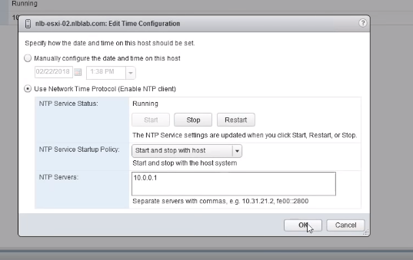

Add the server to the other datacenter.

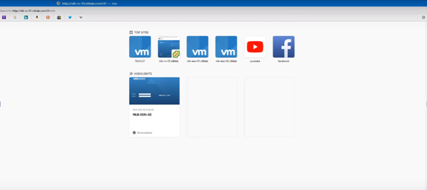

Paste the IP address in the URL, and it connects the server.

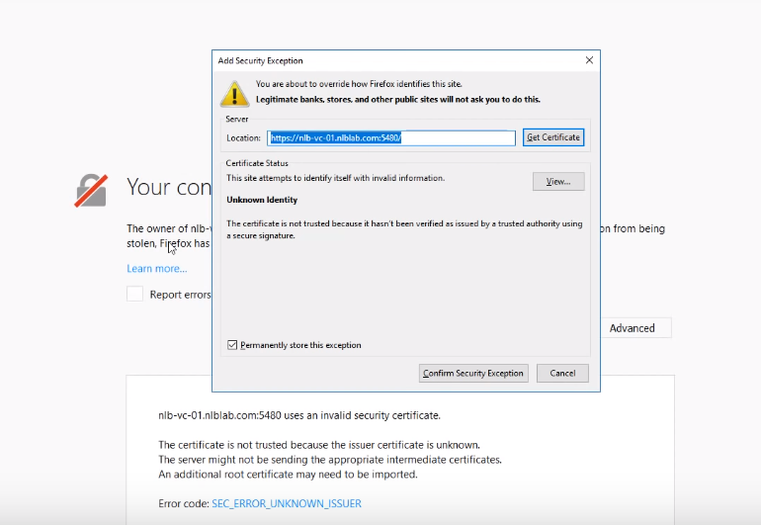

It shows the security option and confirm the security option.

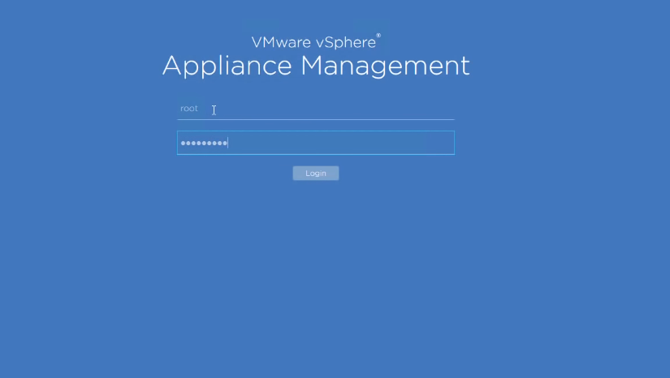

The VMware vSphere appliance management opens and login to the page.

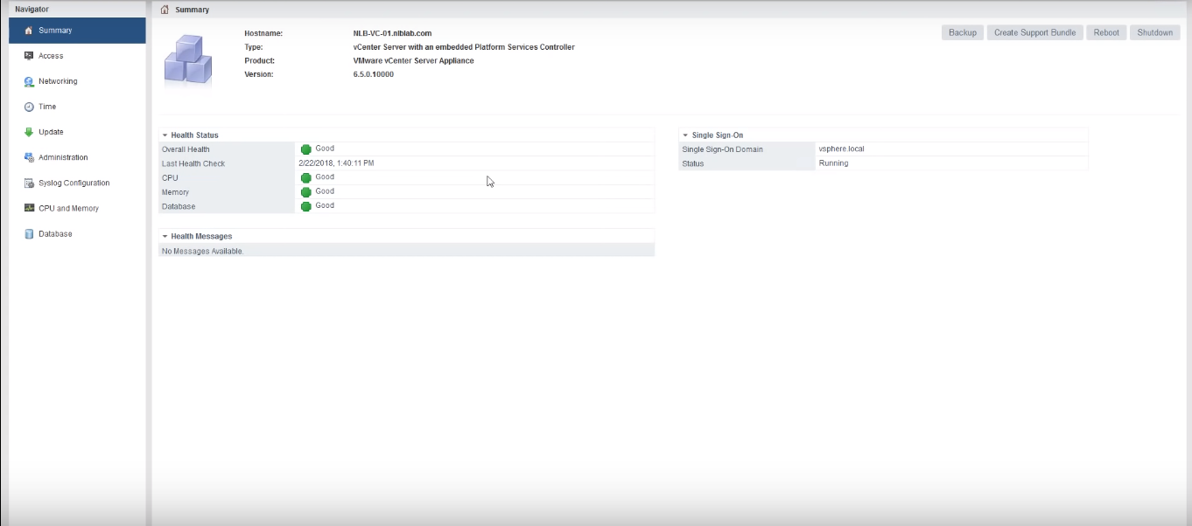

The appliance management page is opened.

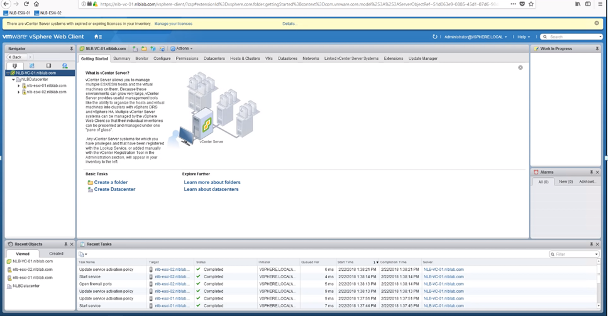

The process is completed on vSphere web client.

# Task 7: Add Your ESXi Hosts to the vCenter Server Inventory

Login to the vcenter server appliance and go to home->vcenter->hosts and clusters.

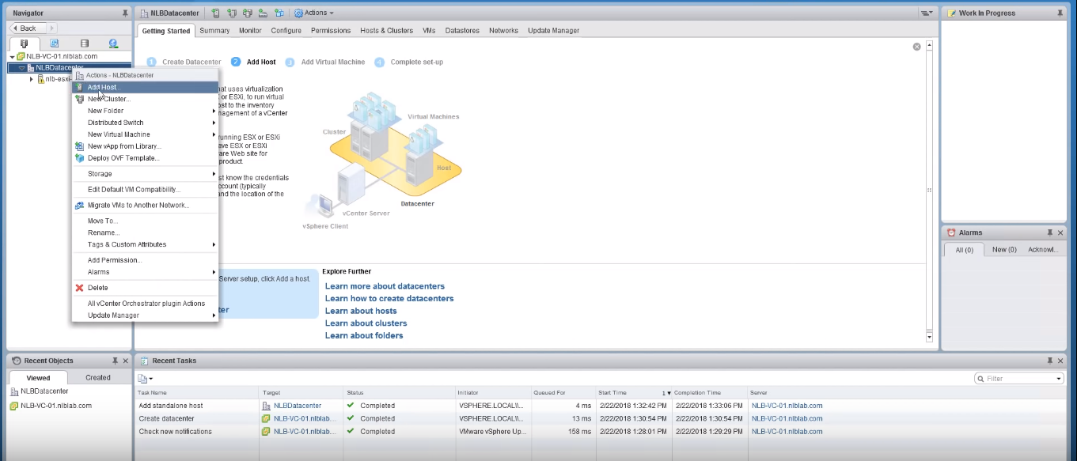

Right click and add the host.

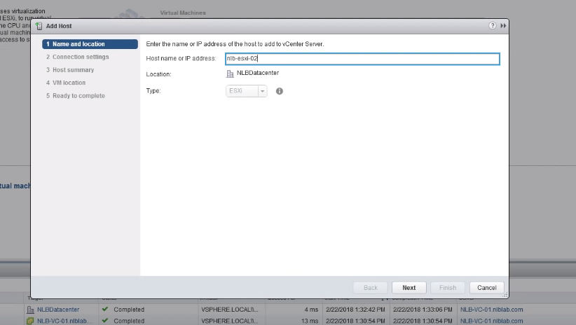

Enter the IP address and click on the Next button.

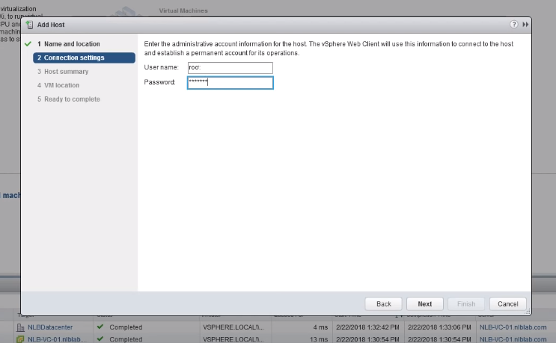

Enter the user name and password, then click on the Next button.

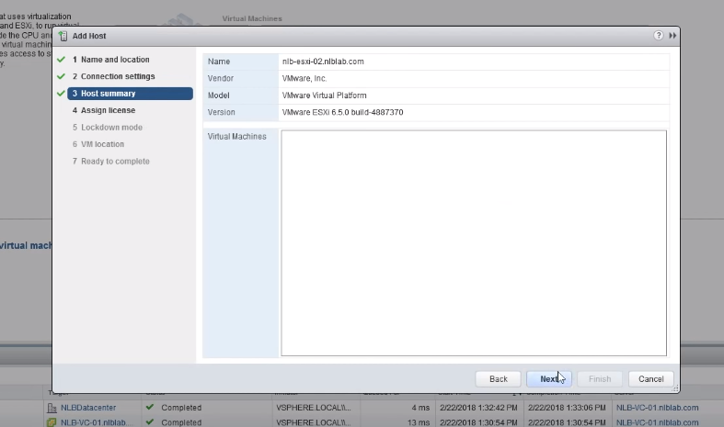

Go to the host summary and click on the Next button.

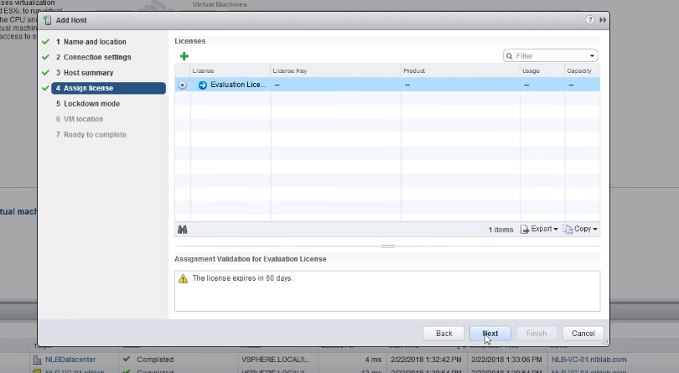

Assign the license and click on the Next button.

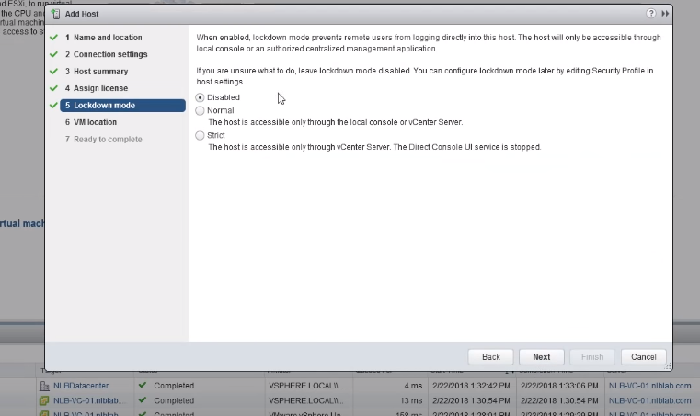

Disable the lockdown mode and click on the Next button.

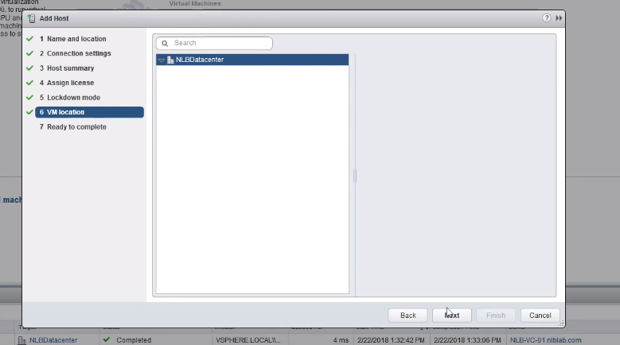

Set the location and click on the Next button.

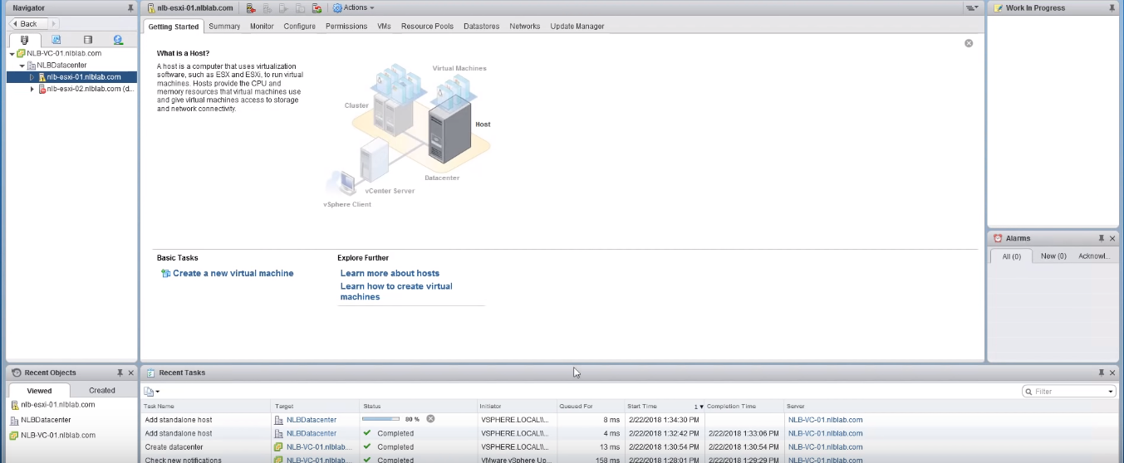

The new data center is created on the server.

# Task 8: Ensure High Availability

The VMware provides high availability for virtual machine that hosts into clusters. If the host or event failure occurs, then it restarts on alternate hosts. High availability means, the system performance is not failed and it gives 100 percentage operational performance. If one host or monitor failed, then it will go to the other host. There are number of hosts available on the virtual machine. The vSphere provides rapid recovery. It protects the server and the server does not fail. If the data store failed, then it restarts the data. The partitioning network is protected by the virtual machine. Increase the application availability and reduce the hardware cost and setup.

# Task 9: Plan and Design Backup Strategy

**Fund:** For active management support for the plan, determine the budget for the data protection plan.

**Evaluate:** The backup is required to retrieve the data. So, analyze the backup needs and evaluate the backup plan for protecting the data.

**Plan:** The data protection requirement has separate backup and recovery plan, for identifying the backup data.

**Implementation:** The entire data has initial backup for both the hardware and software, so schedule the incremental data backup and regular data backup.

**Test:** Finally, test the data backup and recovery process. Recover the software system, then test the client side and sever side backup. Finally, update the data backups and restores.

# Task 10: Reference

VMware vSphere 4 - ESX and vCenter Server. (2019). Retrieved from https://pubs.vmware.com/vsphere-4-esx-vcenter/index.jsp?topic=/com.vmware.vsphere.gsclassic.doc_41/common/install/t_down_client.html

VMware vSphere 5.1. (2019). Retrieved from https://pubs.vmware.com/vsphere-51/index.jsp?topic=%2Fcom.vmware.vsphere.solutions.doc%2FGUID-0A264828-3933-4F4F-82D7-B5006A90CDBA.html